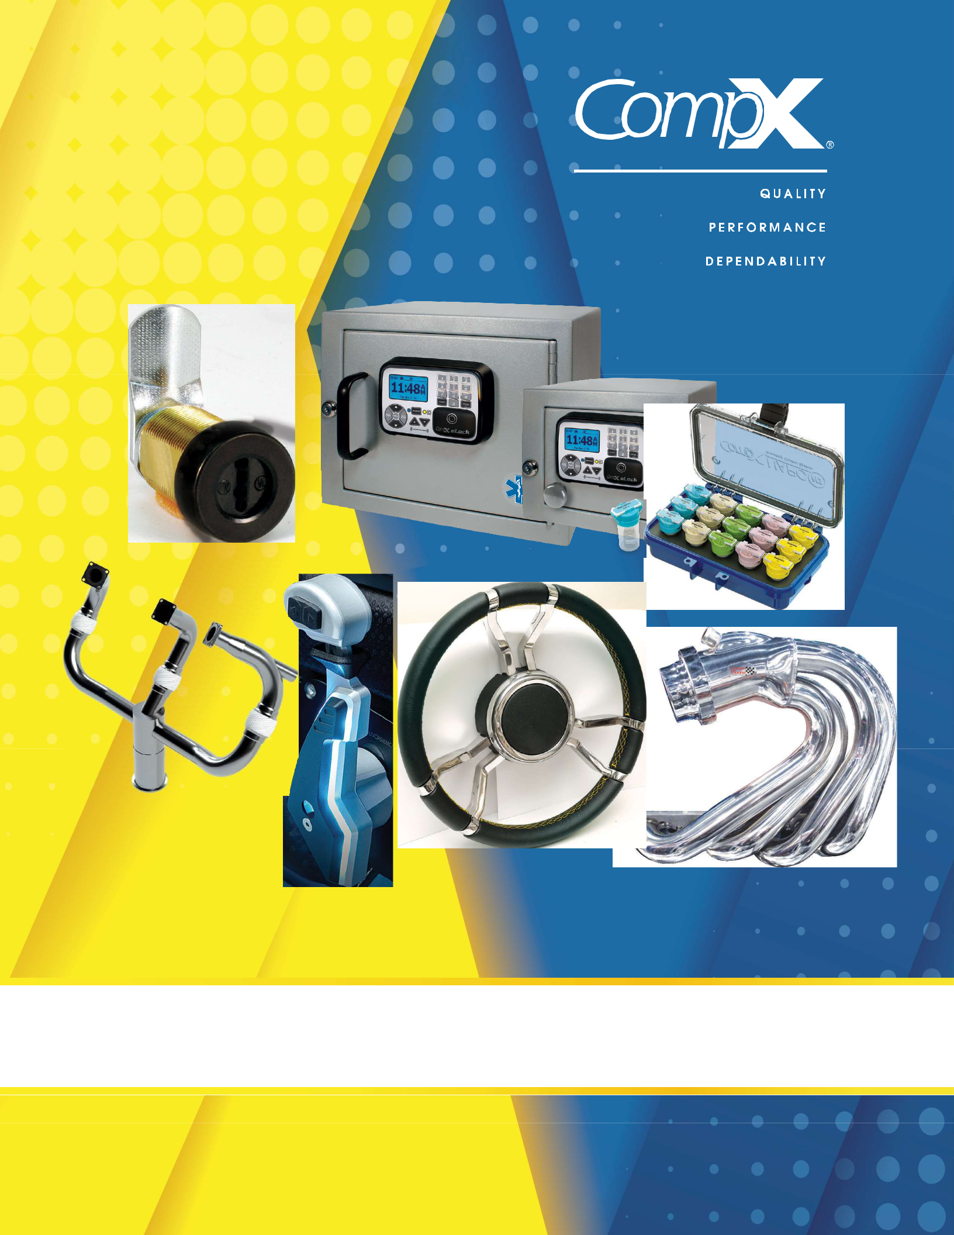

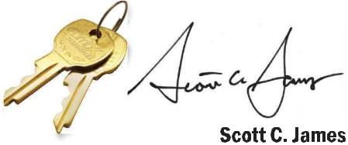

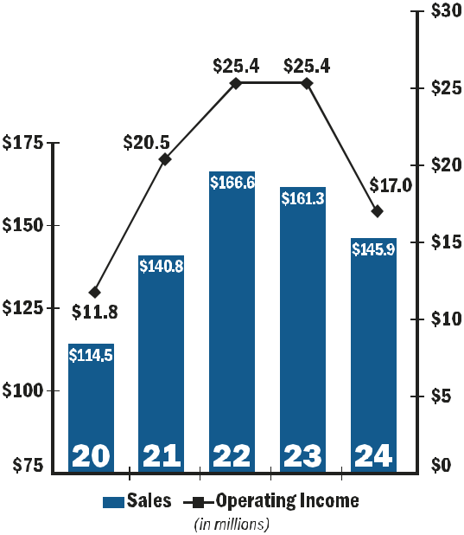




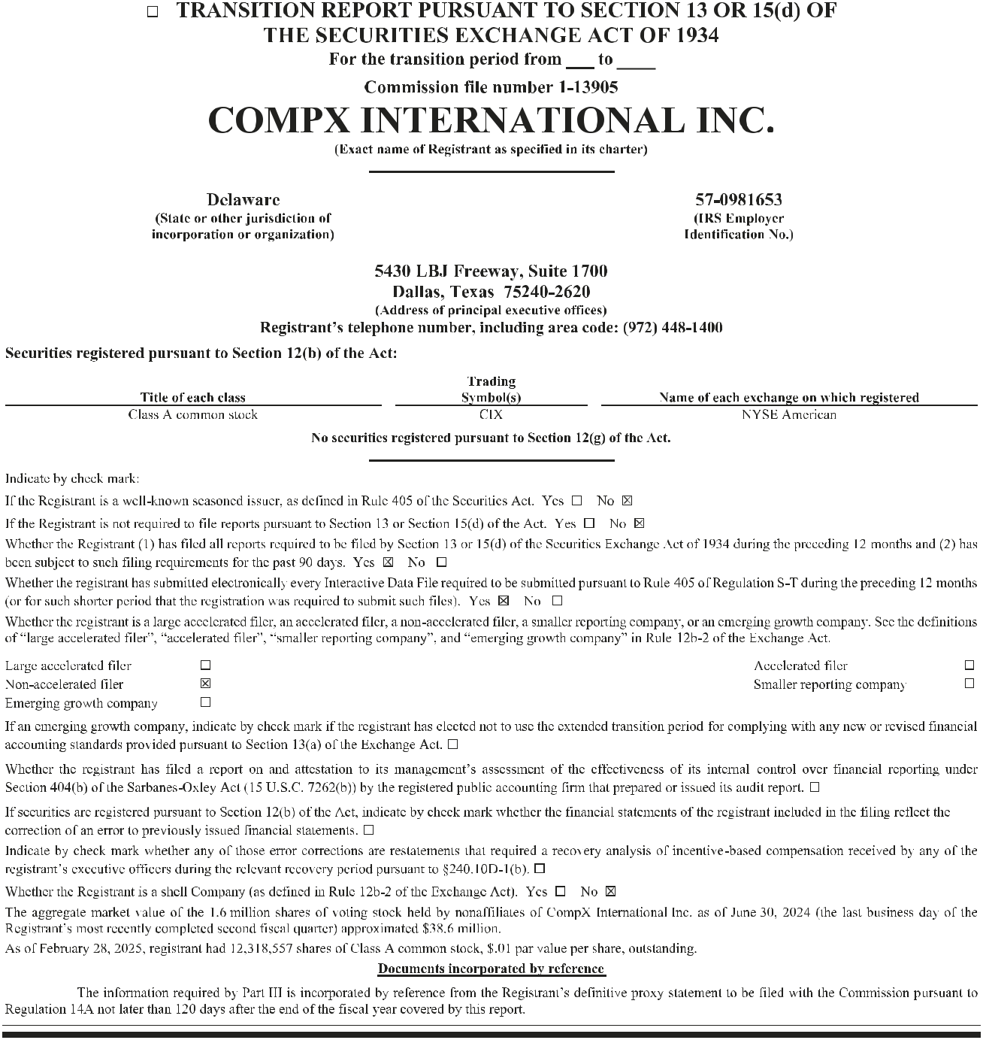

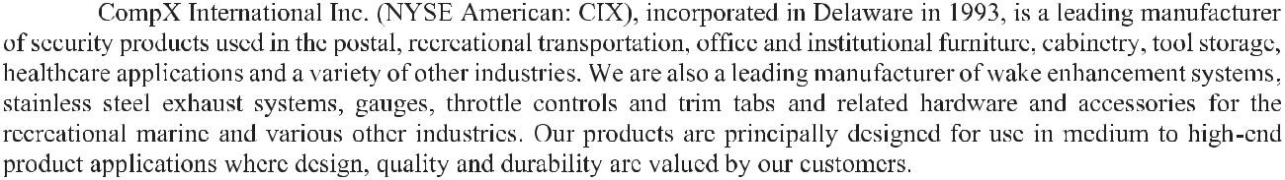
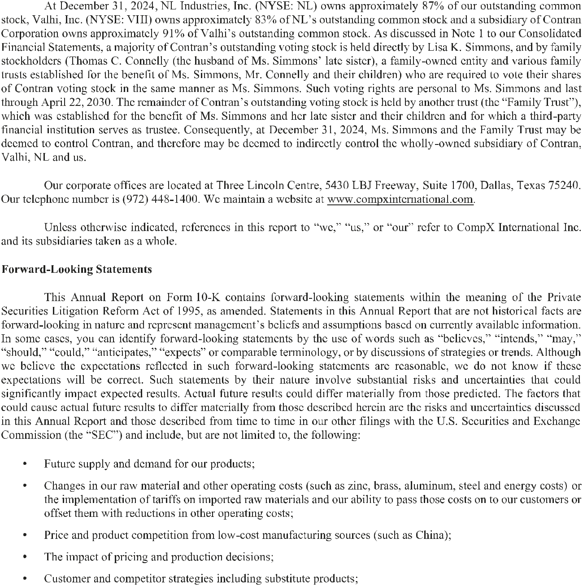

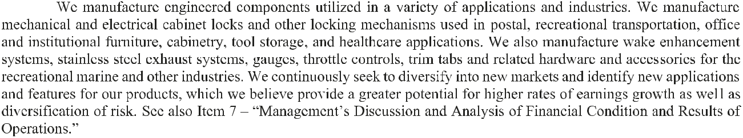

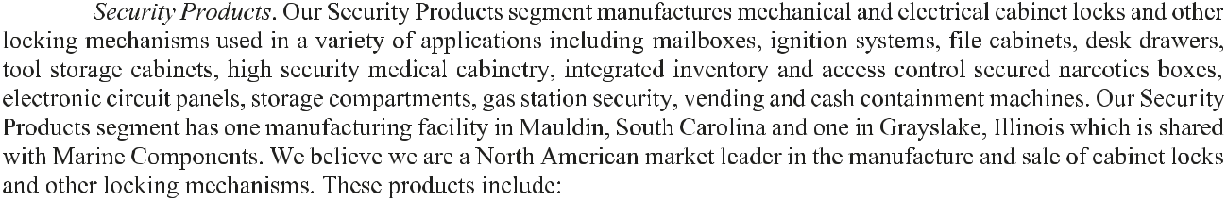
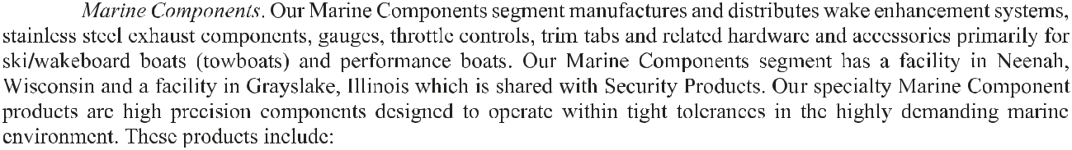

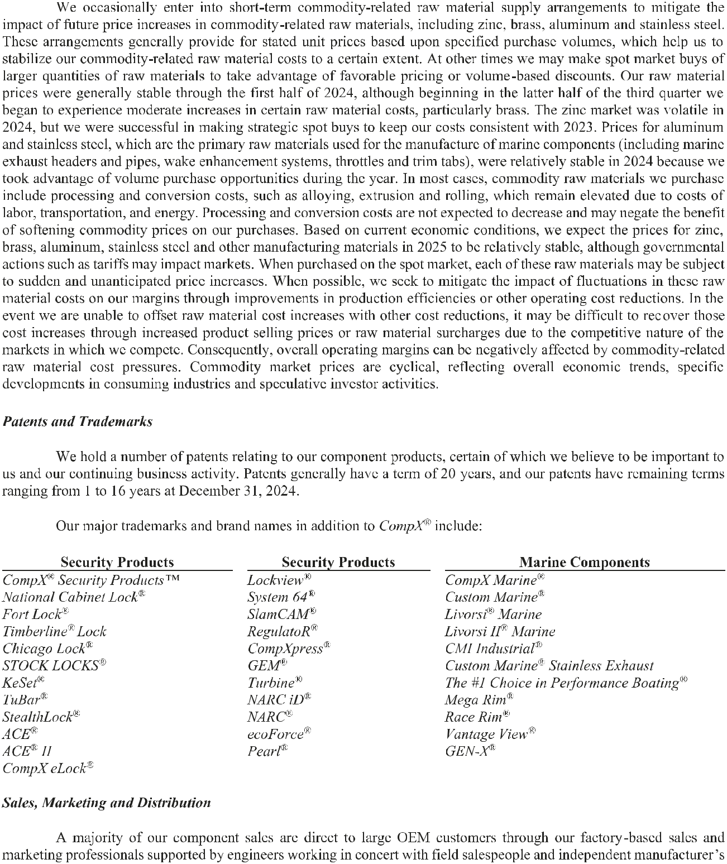

representatives. We select manufacturer’s representatives based on special skills in certain markets or relationships with current or potential customers.

In addition to sales to large OEM customers, a substantial portion of our Security Products sales are made through distributors. We have a significant North American market share of cabinet lock security product sales as a result of the locksmith distribution channel. We support our locksmith distributor sales with a line of standardized products used by the largest segments of the marketplace. These products are packaged and merchandised for easy availability and handling by distributors and end users.

We sell to a diverse customer base with only one customer representing 10% or more of our sales in 2024 (United States Postal Service representing 21%). Our largest ten customers accounted for approximately 47% of our sales in 2024.

Competition

The markets in which we participate are highly competitive. We compete primarily on the basis of product design, including space utilization and aesthetic factors, product quality and durability, price, on-time delivery, service and technical support. We focus our efforts on the middle and high-end segments of the market, where product design, quality, durability and service are valued by the customer. Our Security Products segment competes against a number of domestic and foreign manufacturers. Our Marine Components segment competes with small domestic manufacturers and is minimally affected by foreign competitors.

Environmental, Social and Governance (“ESG”)

We seek to operate our business in line with sound ESG principles that include corporate governance, social responsibility, sustainability and cybersecurity. We believe ESG means conducting operations with high standards of environmental and social responsibility, practicing exemplary ethical standards, focusing on safety as a top priority, respecting human rights and supporting our local communities, and continuously developing our employees. At our facilities, we undertake various environmental sustainability programs, and we promote social responsibility and volunteerism through programs designed to support and give back to the local communities in which we operate. Each of our locations maintains site-specific safety programs and disaster response and business continuity plans. All manufacturing facilities have detailed, site-specific emergency response procedures we believe adequately address regulatory compliance, vulnerability to potential hazards, emergency response and action plans, employee training, alarms and warning systems and crisis communication.

In an effort to align our non-employee directors’ financial interests with those of our stockholders, our board of directors established share ownership guidelines for our non-management directors. In addition, we have adopted an insider trading policy that applies to both employees and non-employee directors.

Regulatory and Environmental Matters

We have a history of incorporating environmental management and compliance in our operations and decision making. We operate three manufacturing facilities and our production processes requiring waste-water discharge are consolidated at our Mauldin, South Carolina facility. This facility has received a ReWa Compliance Excellence Award multiple years for its exemplary performance from Renewable Water Resources, an organization which sets regulatory and water policies for the Mauldin facility’s geographic region. In addition, we operate extensive scrap metal recycling programs to reduce landfill waste.

Our operations are subject to federal, state and local laws and regulations relating to the use, storage, handling, generation, transportation, treatment, emission, discharge, disposal, remediation of and exposure to hazardous and non-hazardous substances, materials and wastes, some of which are becoming stricter over time. Our operations also are subject to federal, state and local laws and regulations relating to worker health and safety. We believe we are in substantial compliance with all such laws and regulations. To date, the costs of maintaining compliance with such laws and regulations have not significantly impacted our results; however, it is possible future laws and regulations may require us to incur significant additional expenditures.

- 6 -





