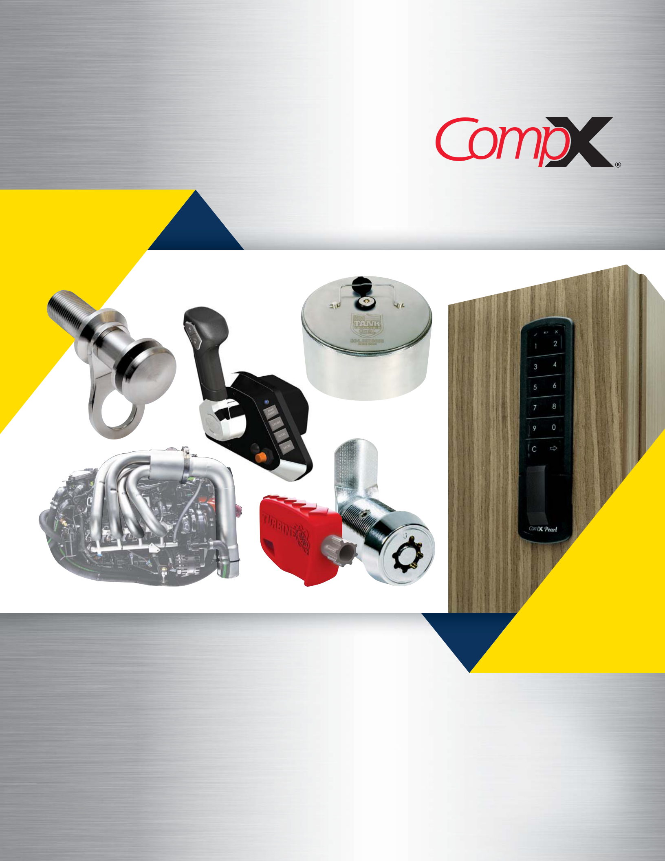

2022 ANNUAL REPORT

COMPONENT EXCELLENCE

QUALITY

PERFORMANCE

DEPENDABILITY

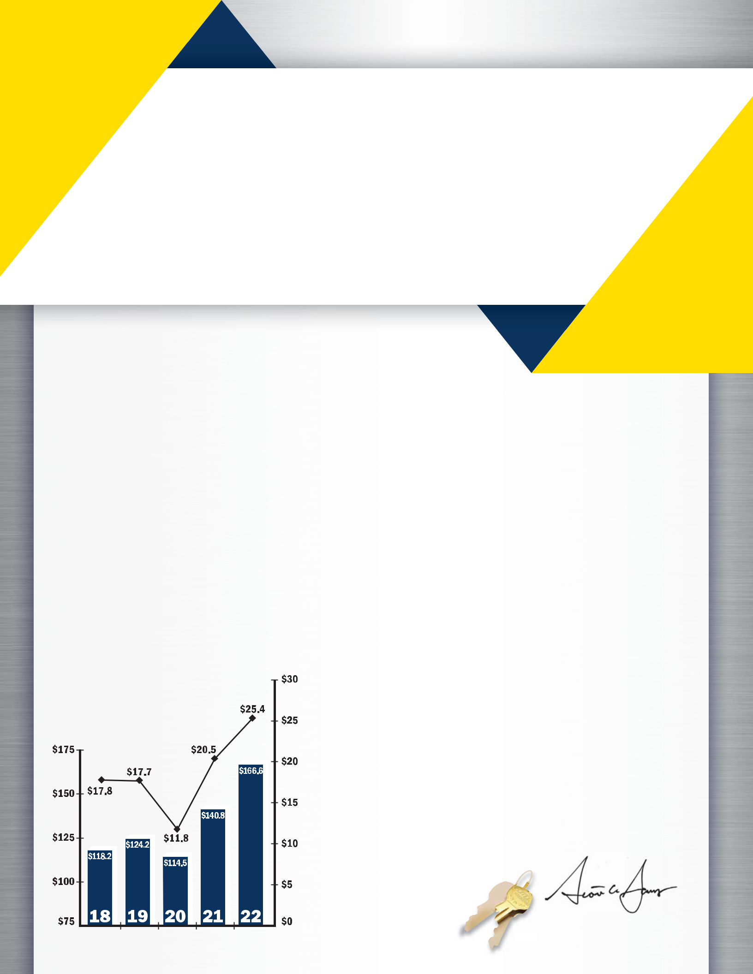

MESSAGE TO OUR STOCKHOLDERS

2022 was a record-breaking year for both of our segments with consolidated revenues increasing 18% and earnings per share improving to $1.69 for the year. CompX Marine led the way with an impressive 46% increase in net sales from the prior year fueled by sustained growth in the recreational boat markets. CompX Security Products also delivered 9% sales growth driven by strong demand in the government security, office furniture and distribution markets. While supply chains stabilized during the year, raw material costs remained high and wage pressures increased leading to higher production costs throughout 2022. Customer price increases were required to mitigate the higher material and production costs which increased operating income margin at CompX Marine to 18.4% while CompX Security Products operating income margin declined slightly to 19.9%.

We take great pride in operating at high customer service levels and delivering world-

Sales & Operating Income

Sales Operating Income

class and innovative products to our new and existing customers in expanding markets while maintaining a focus on prudent use of capital. When signs of an economic slow-down began to emerge in the second half of 2022, we pulled back from our planned capital spend of $6.7 million and ended the year making $3.7 million of capital investments focused on increasing capacity and improving our production capabilities. Our growth in sales has required higher levels of working capital to maintain our business, but our investments during 2021, along with our record-breaking net income, provided strong cash flows from operating activities of $16.9 million in 2022. On the strength of our financial performance, in August 2022 we paid a special dividend of $1.75 per share.

We believe our keys to success lie in our attention to innovation, product and market diversification, new product development and strong customer relationships.

Over the last few years, CompX Security Products has introduced new mechanical and electronic

lock solutions to grow sales in a number of markets, most notably government security and healthcare, and we are actively working to identify, develop and refine new and existing products that will continue to help grow our business and benefit our customers. CompX Marine continues to innovate, grow and diversify its component solutions for a wide range of boating, including ski and towboats,

center-console recreational craft, performance and fishing boats.

Near the end of 2022 a slowing U.S. economy began impacting demand at CompX Security Products and at the beginning of 2023 we began to see similar demand softness at CompX Marine. We are in regular communication with our customers to best manage our inventory levels through an economic slow-down. For CompX Marine we expect 2023 to represent more normalized sales volumes after two years of unprecedented growth. While CompX Security Products will also be impacted by general economic conditions, with its diverse customer base, we believe it is well positioned to respond when growth returns. We are tightening our belt as we manage costs and limit capital spending through the slow-down. Although we expect 2023 to be challenging, given our strong balance sheet and history of positive cash flows through up and down cycles, we are well positioned to maintain our consistent dividends. We believe maintaining safe manufacturing facilities is mission critical and we work with our employees to ensure each facility meets our standards of excellence. We are focused on returning value to stockholders and we believe we have the leadership, work force and infrastructure to navigate through near-term economic headwinds while continuing to deliver long-term sustainable growth for the benefit our stockholders.

Scott C. James
President and Chief Executive Officer

(in millions)






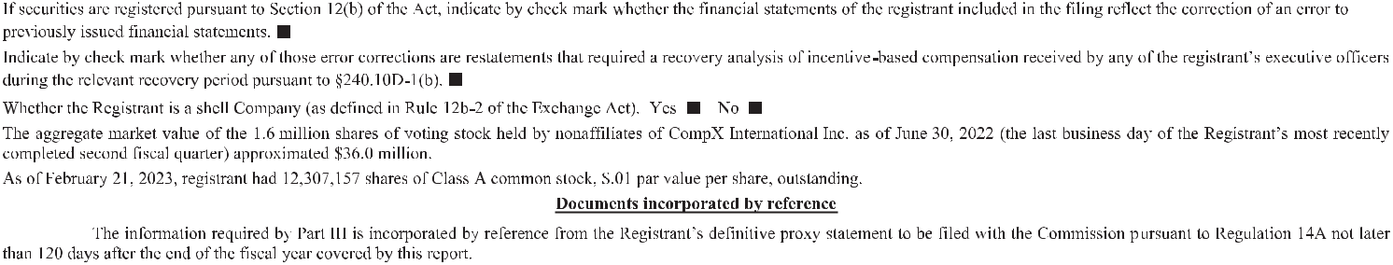

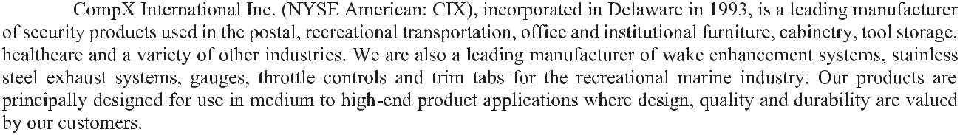
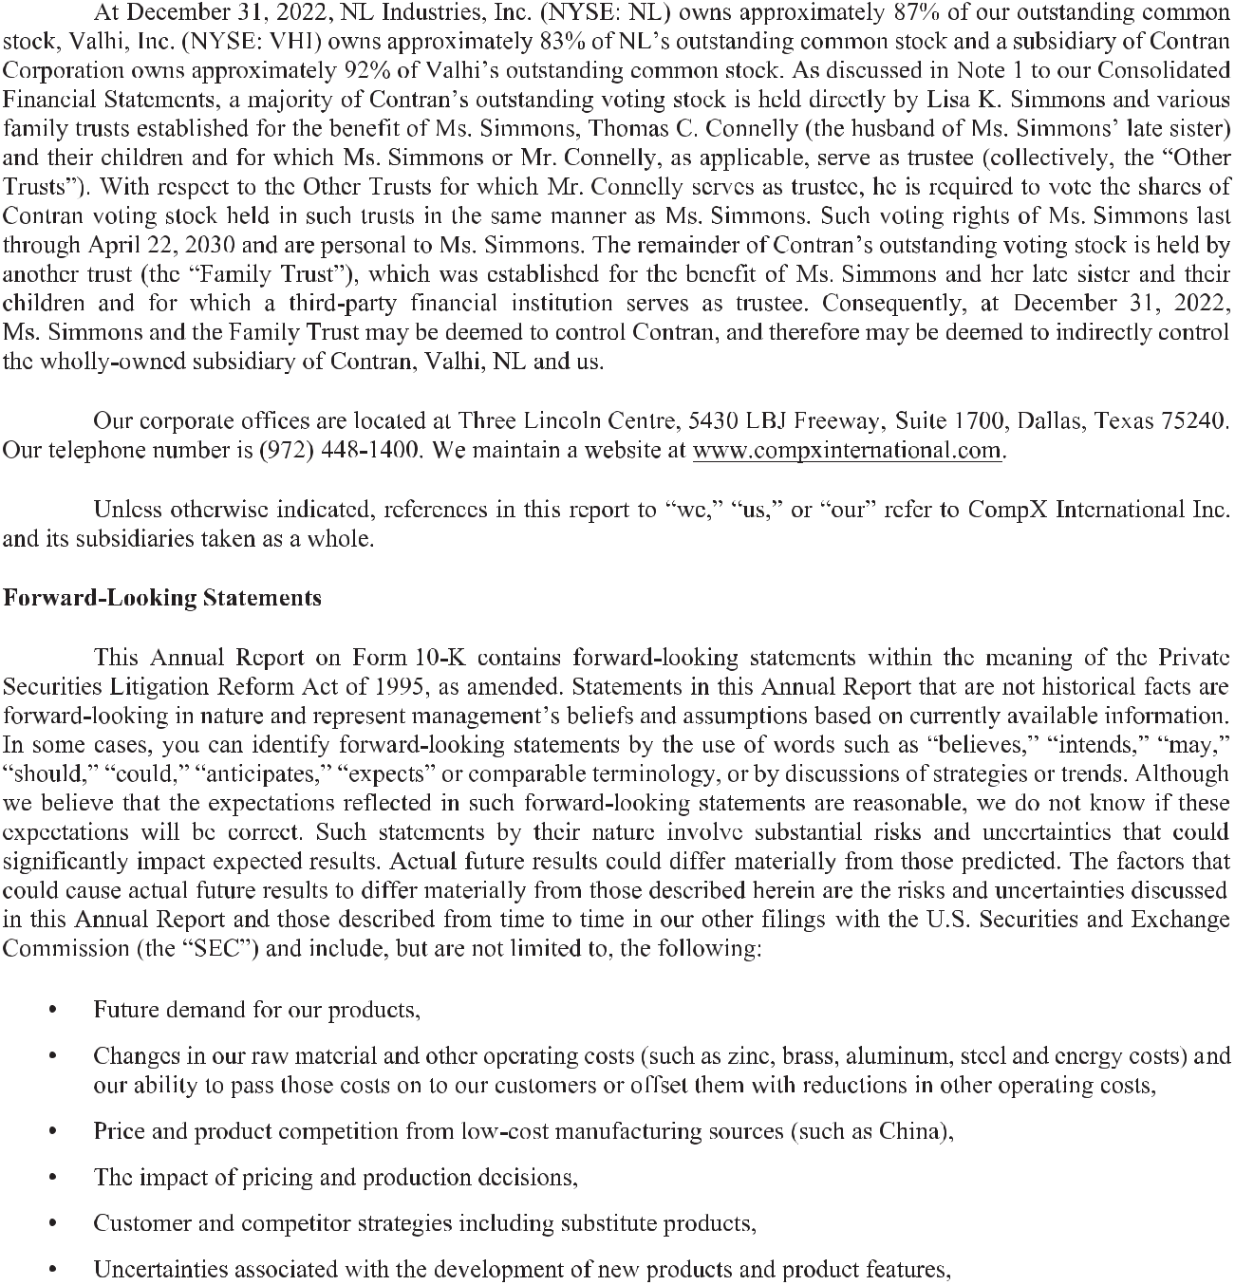

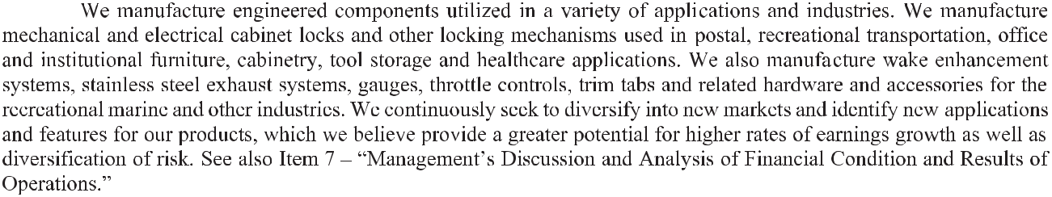
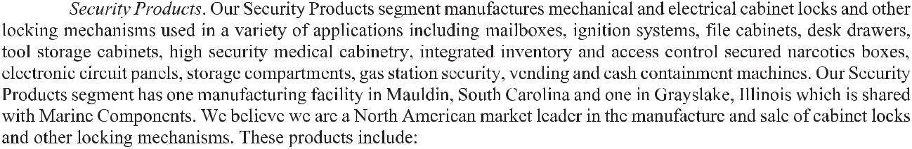

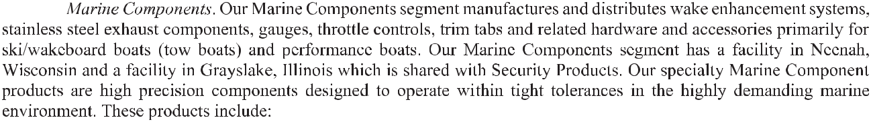
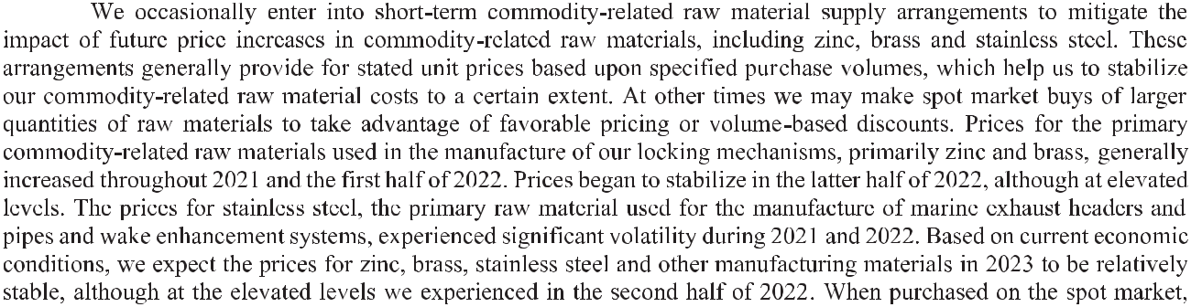

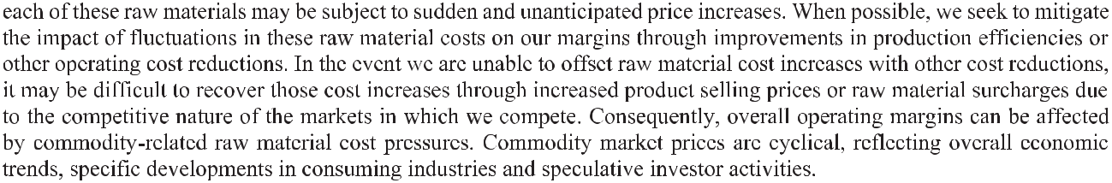
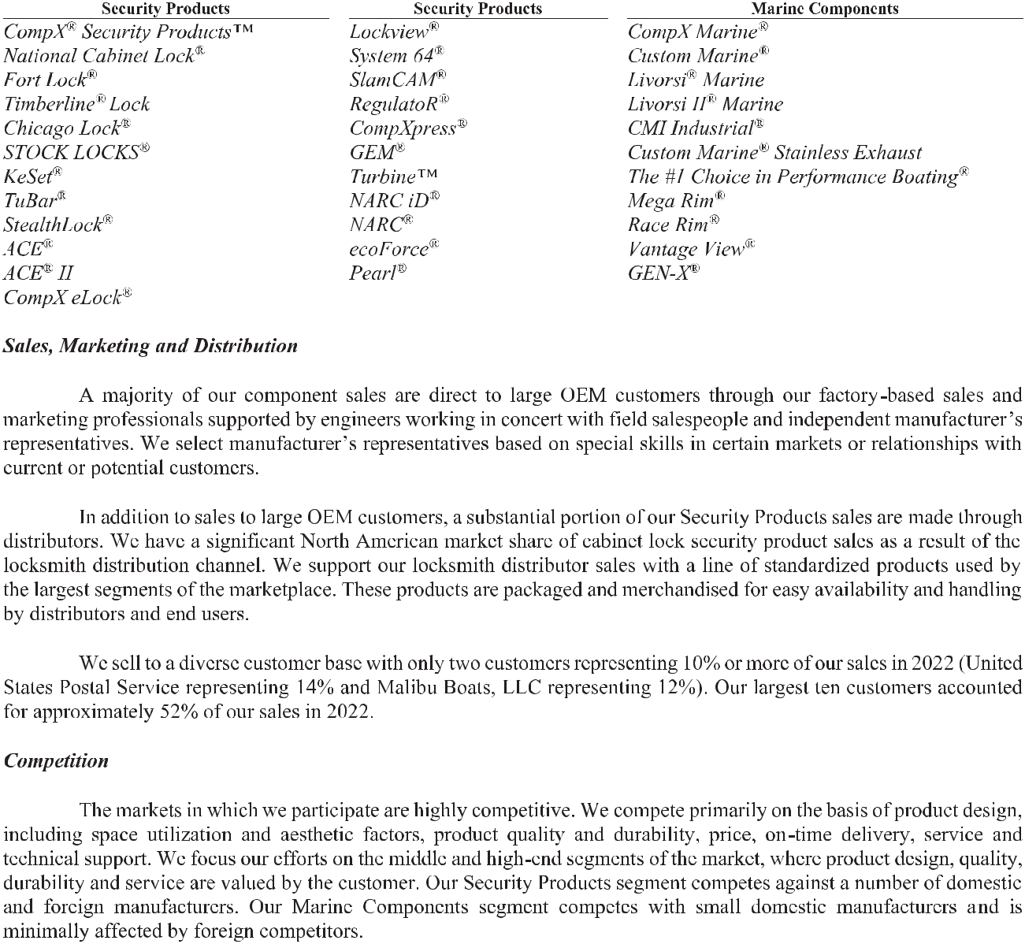

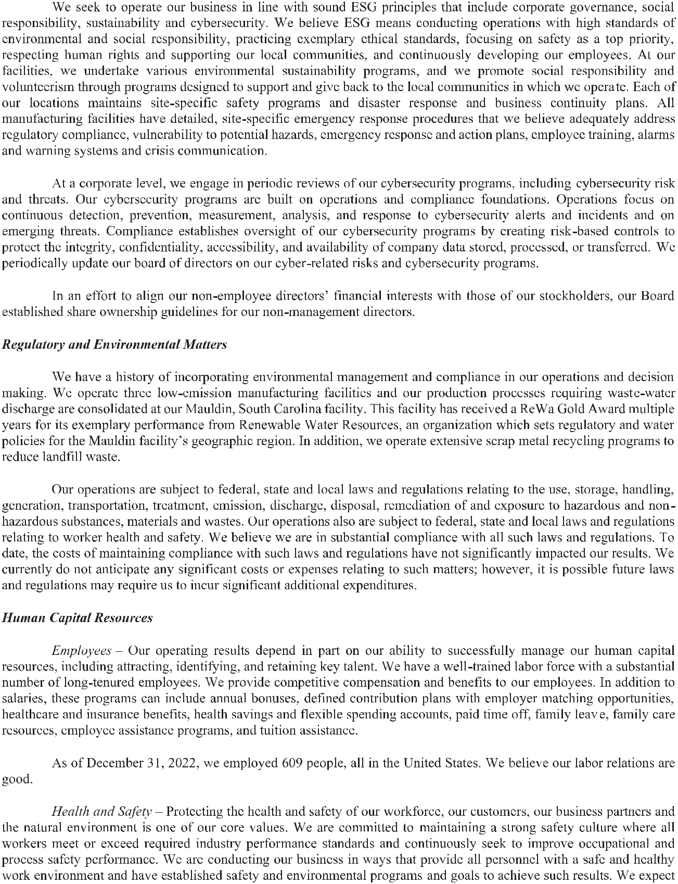

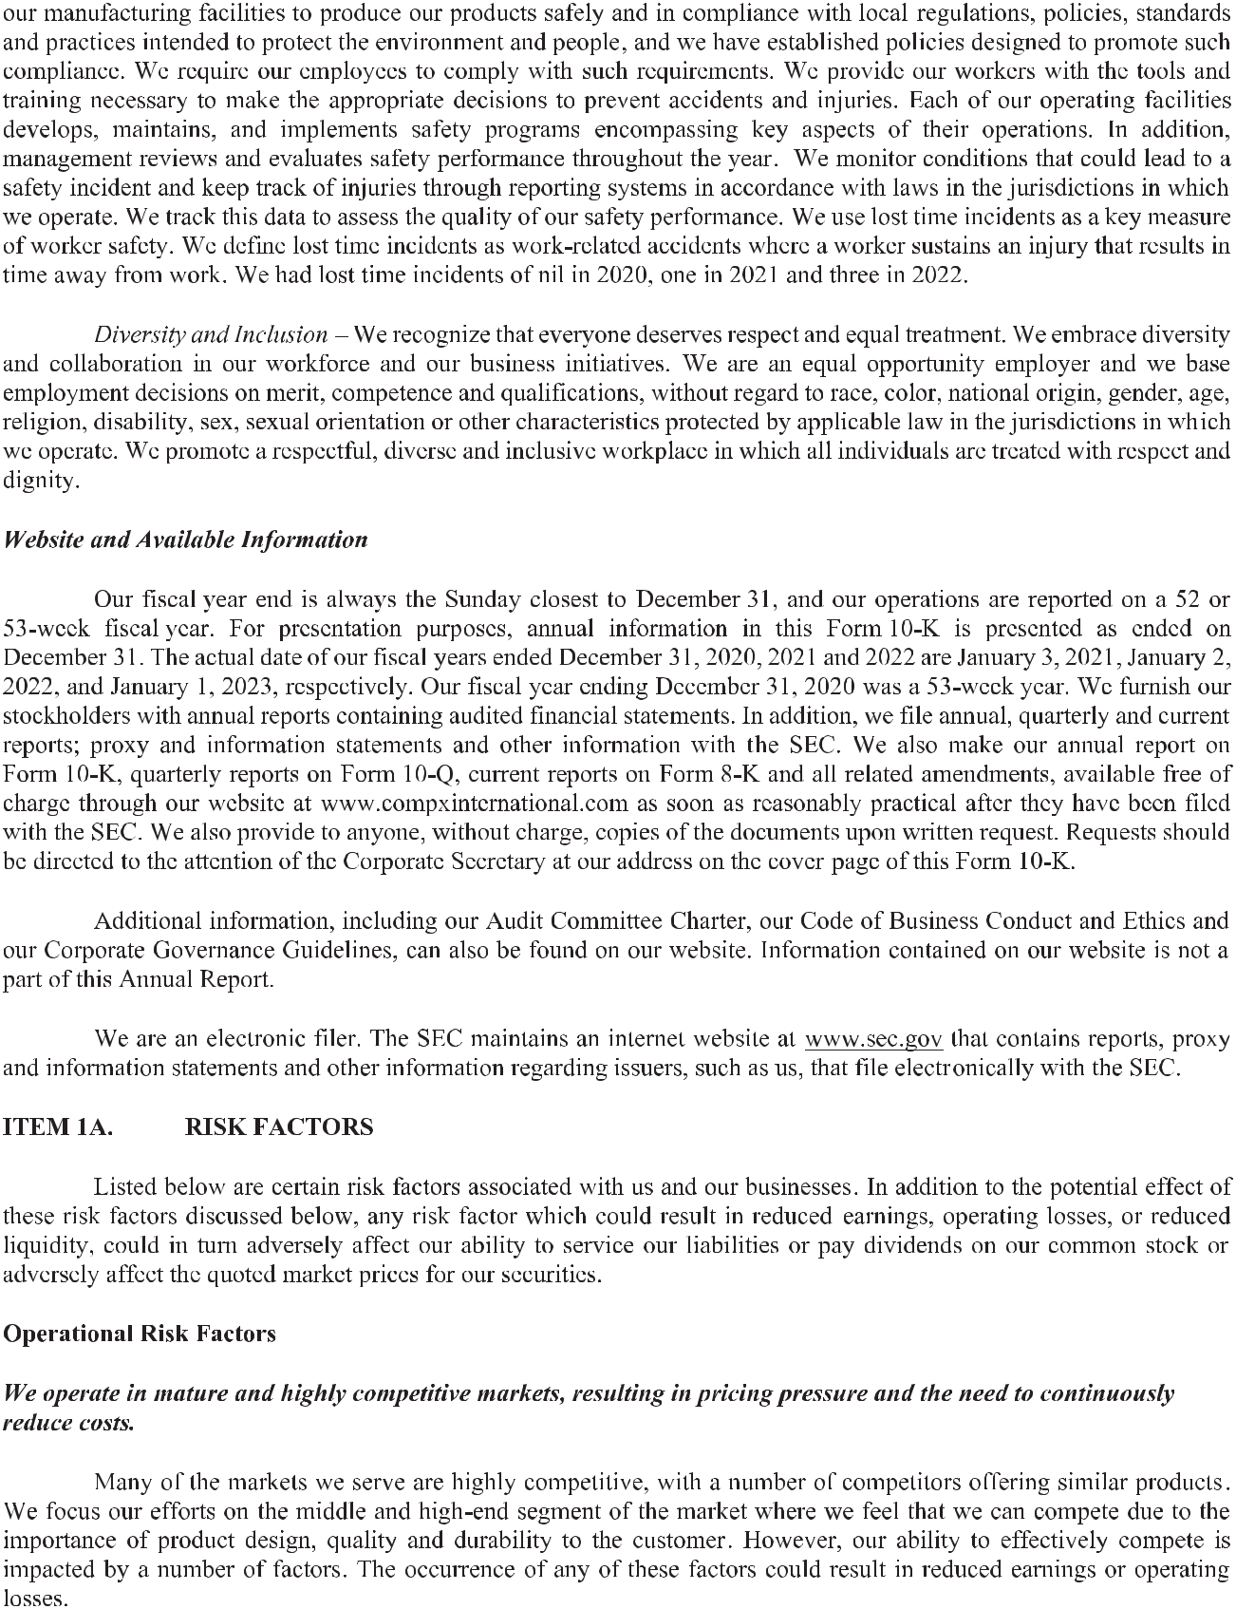

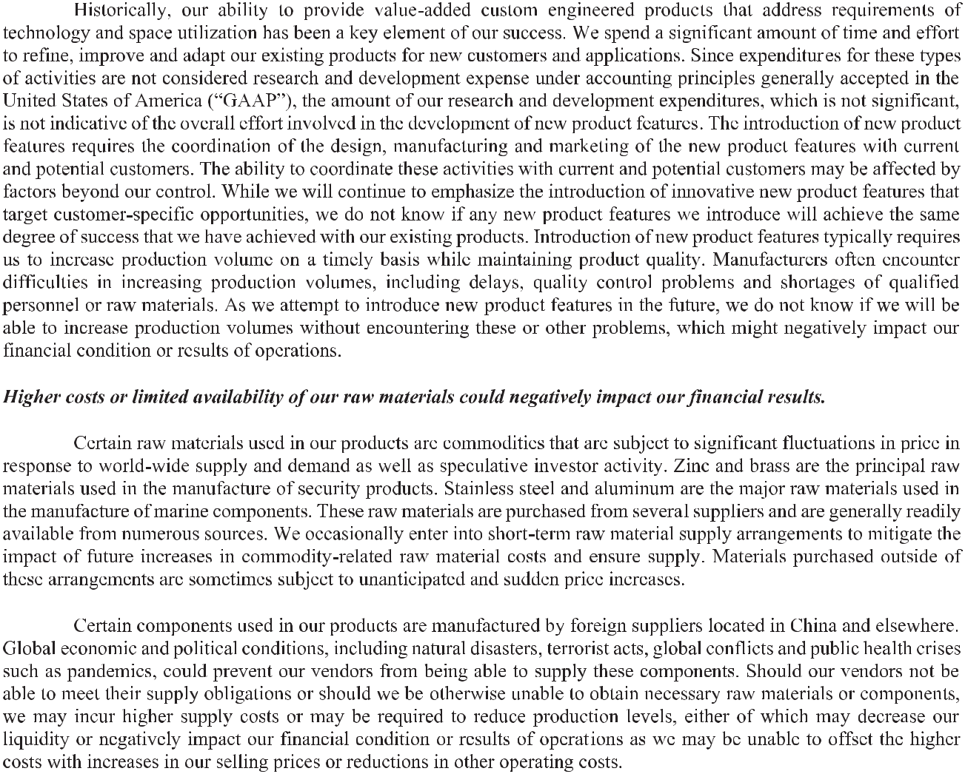

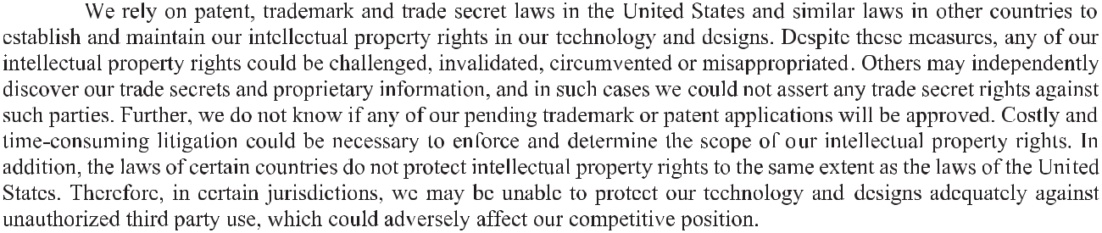
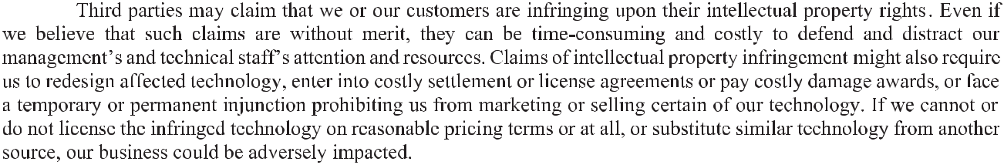
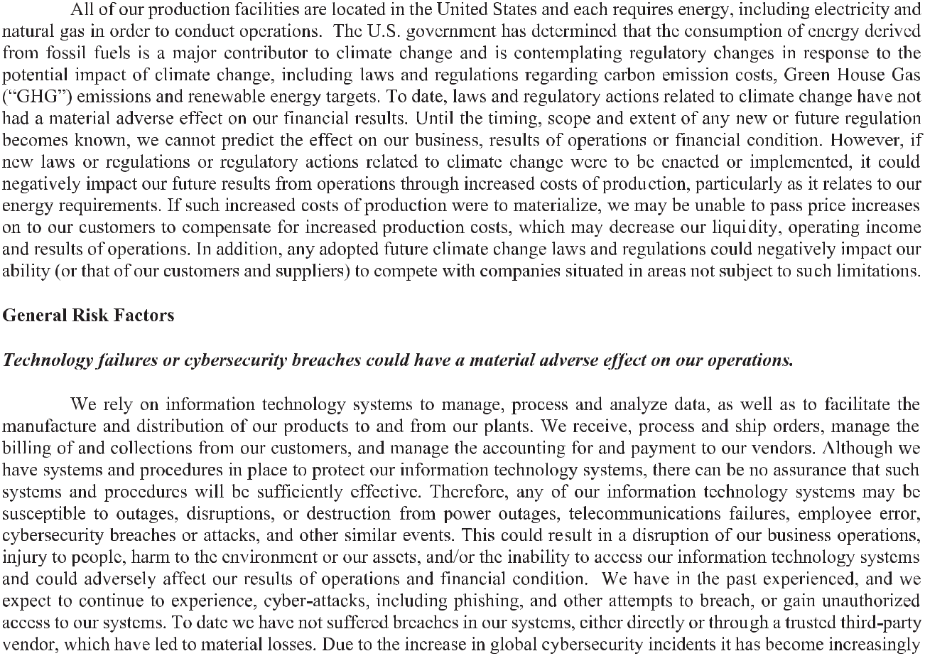

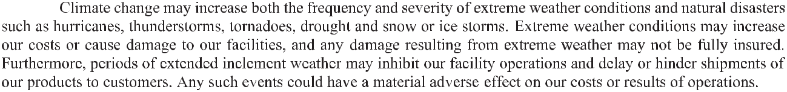
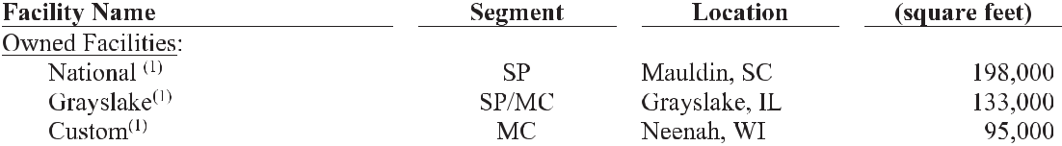
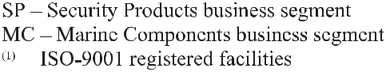

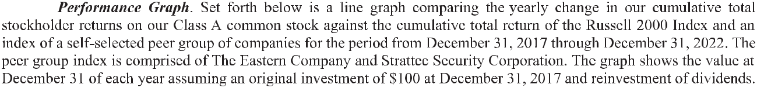
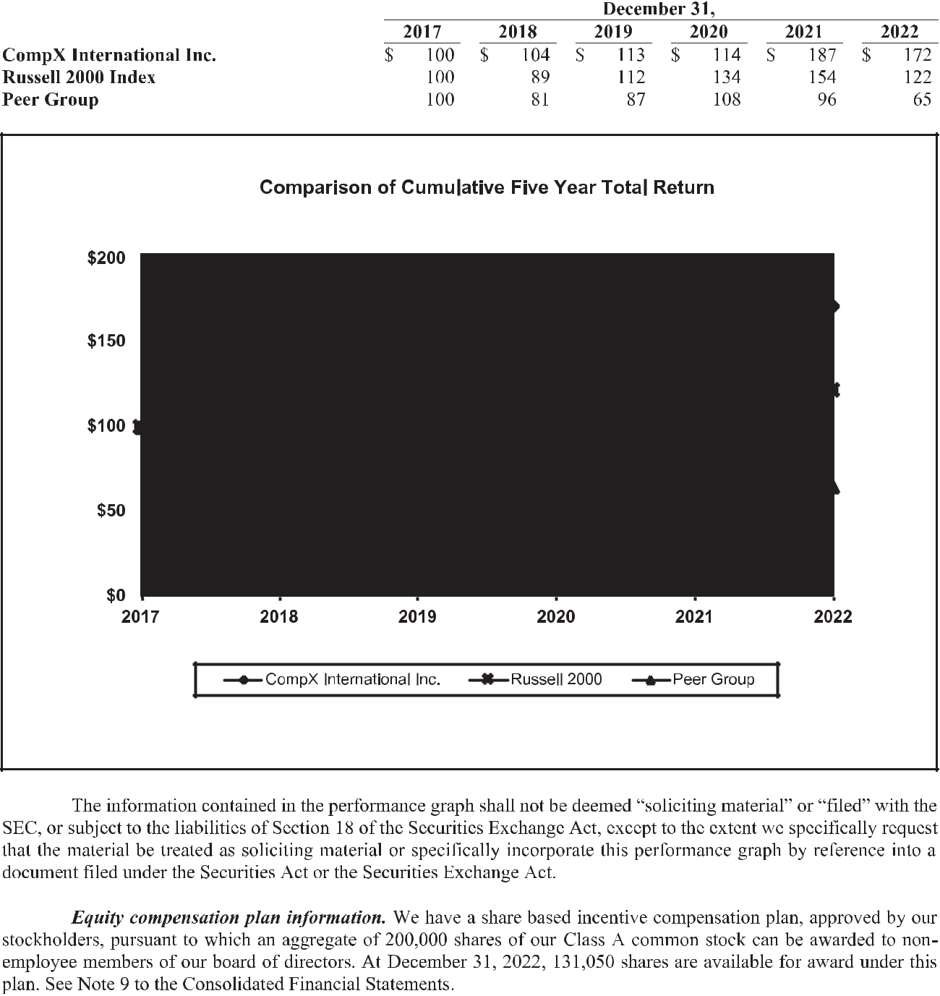

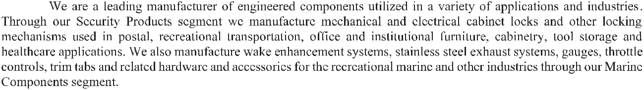
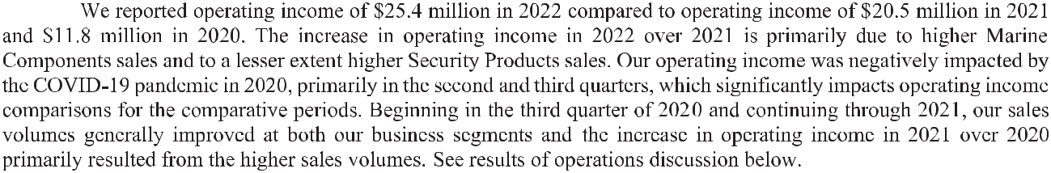
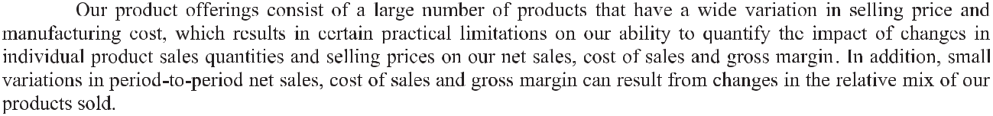
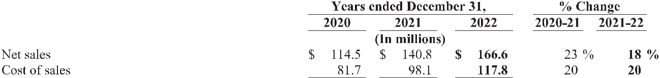

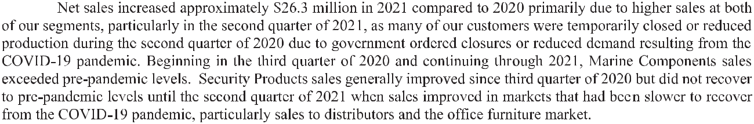
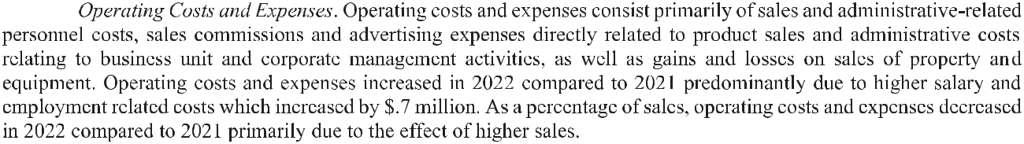
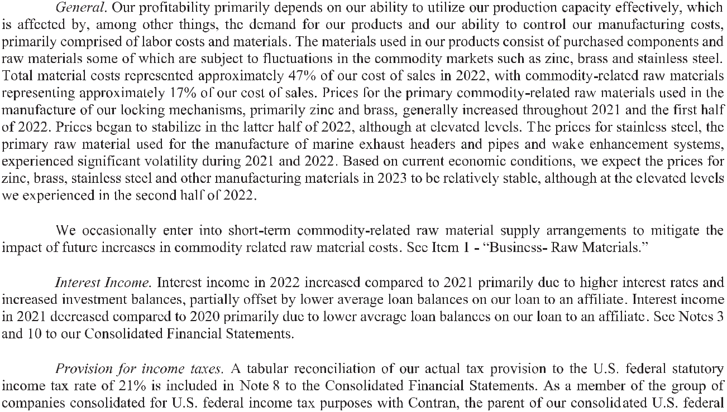

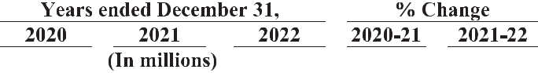
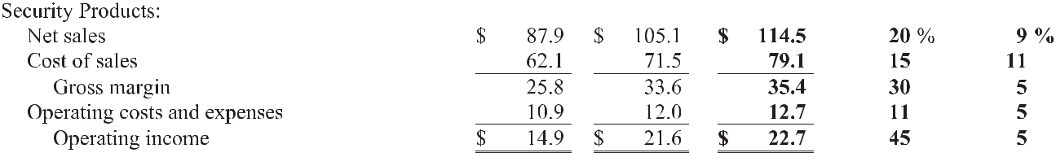
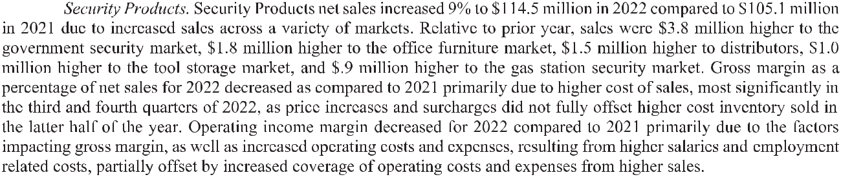
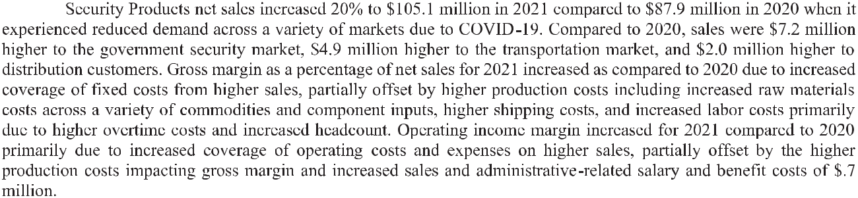

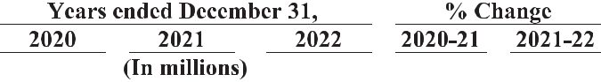
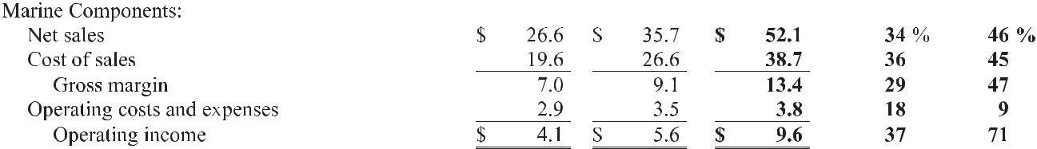
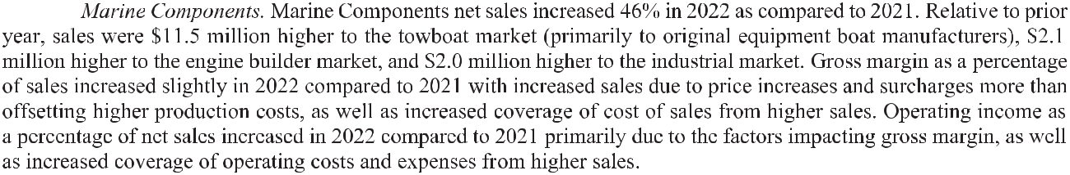
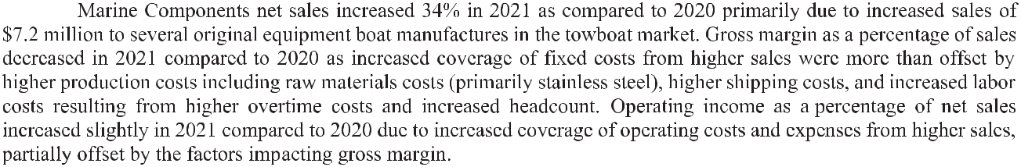
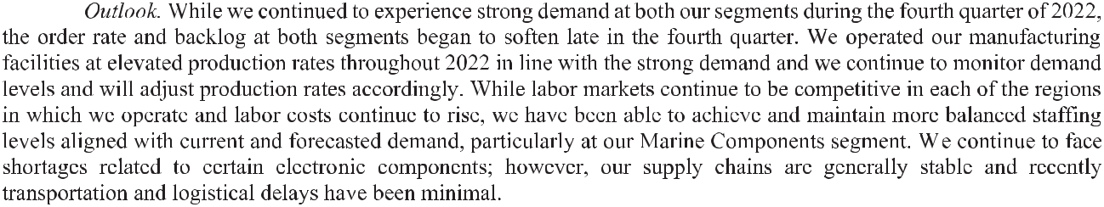
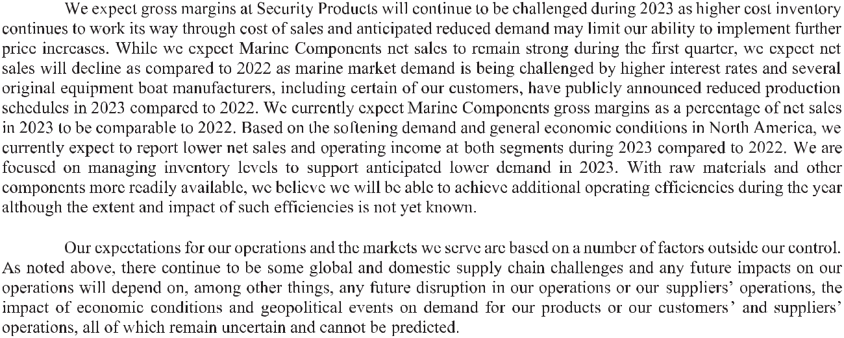

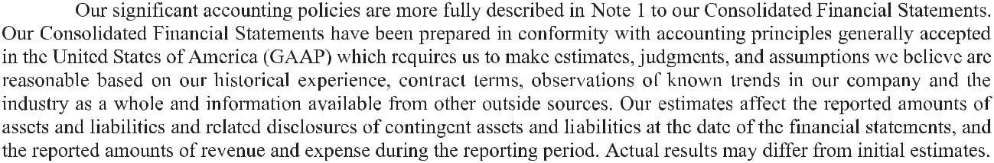
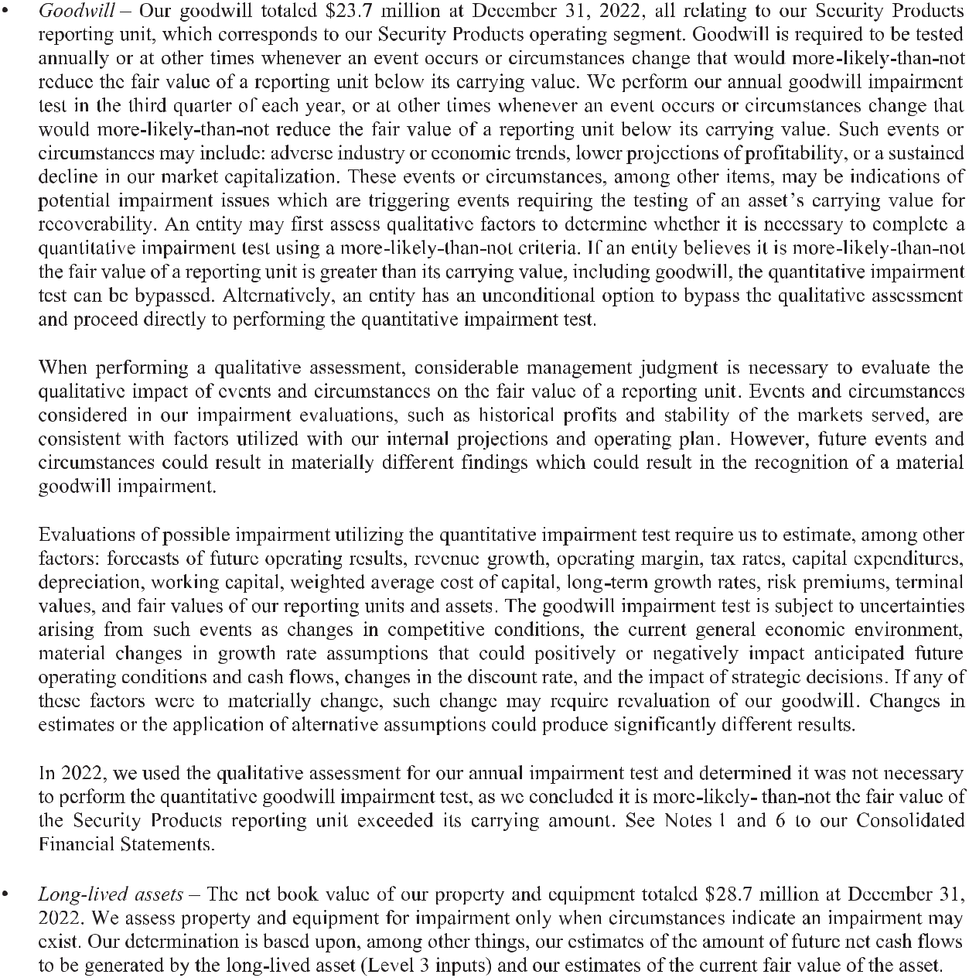

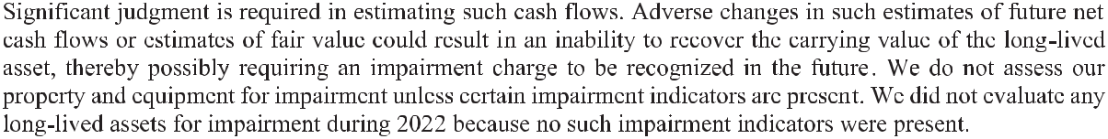
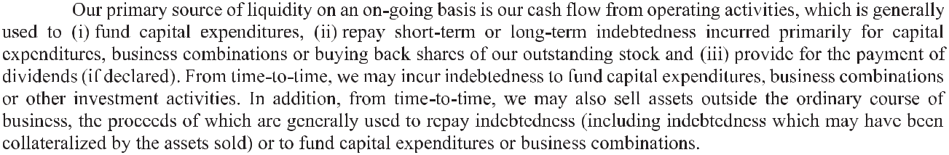
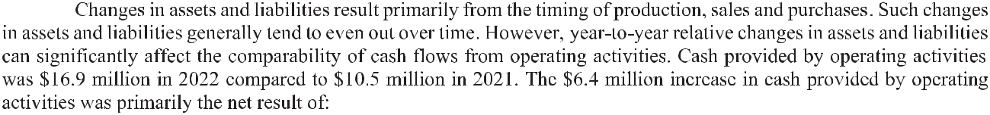

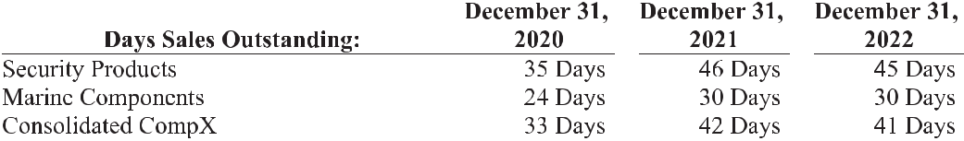
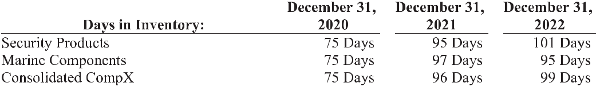
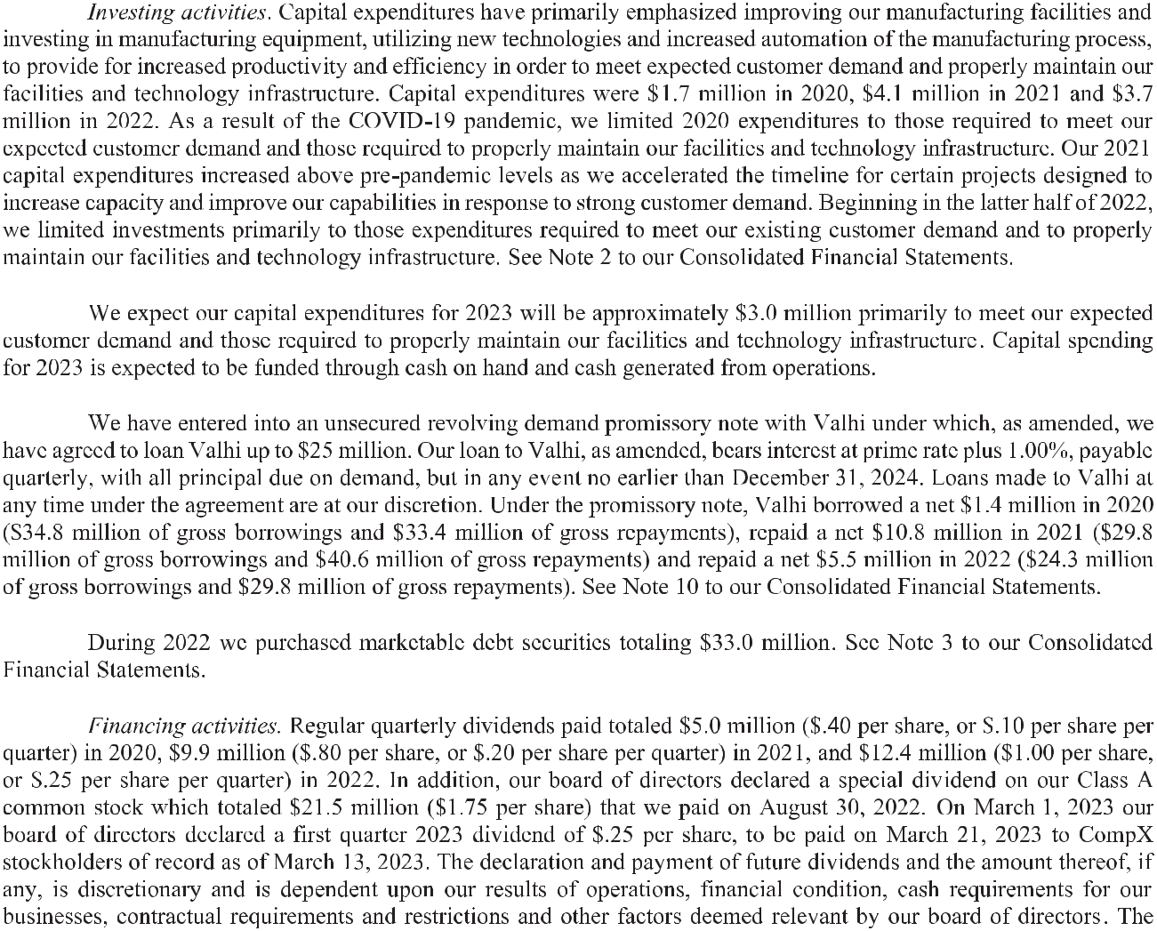

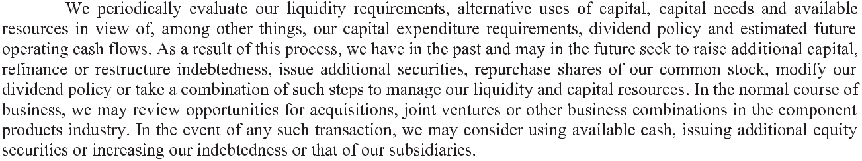
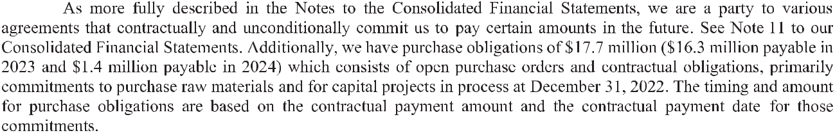
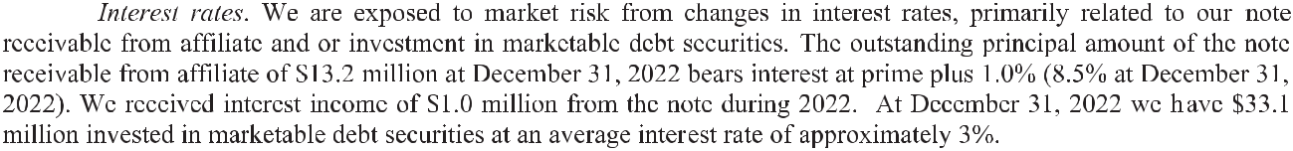
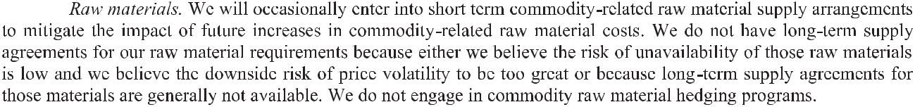

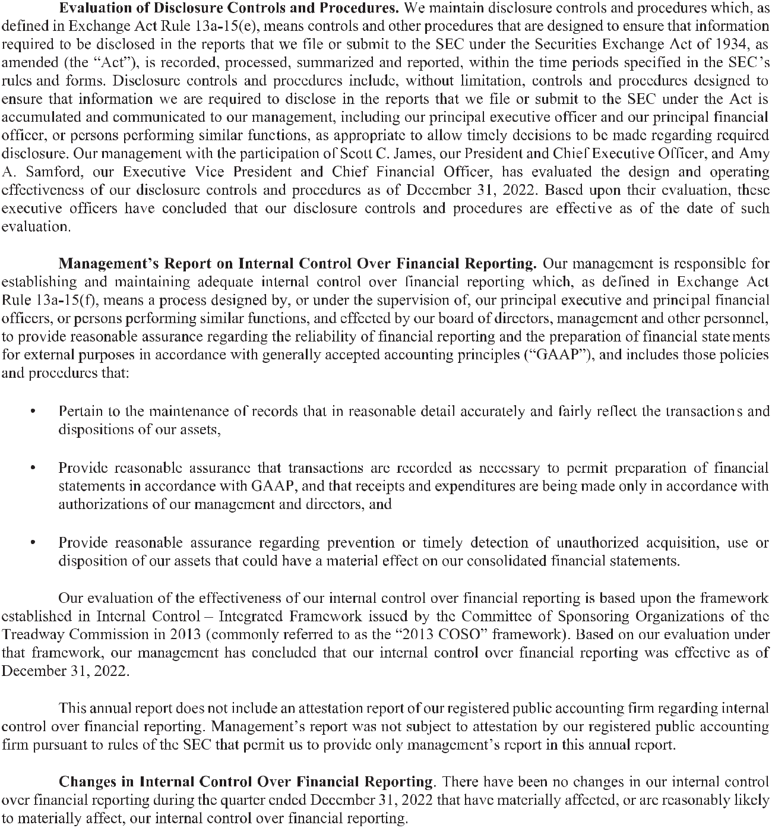

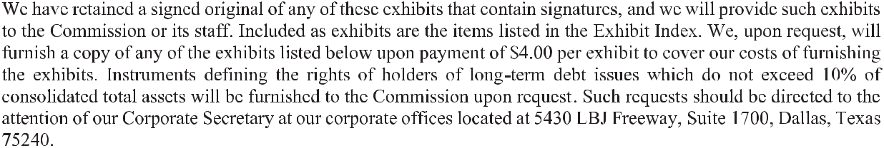
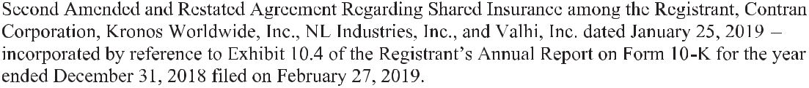

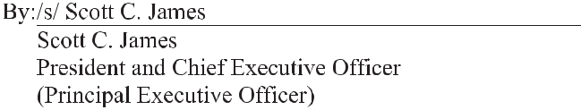
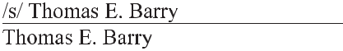
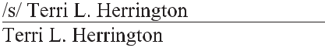
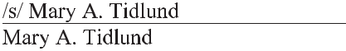

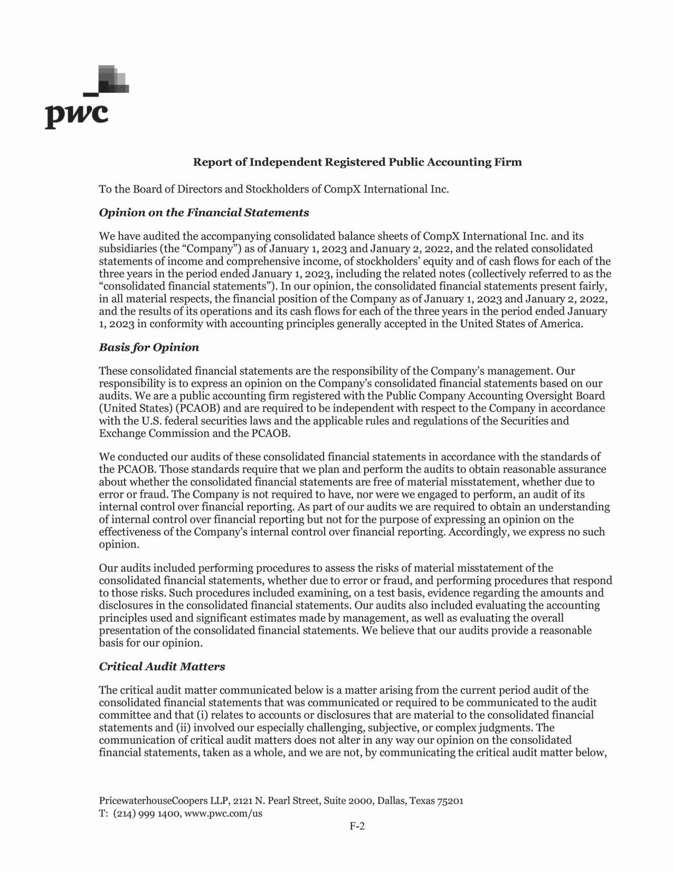

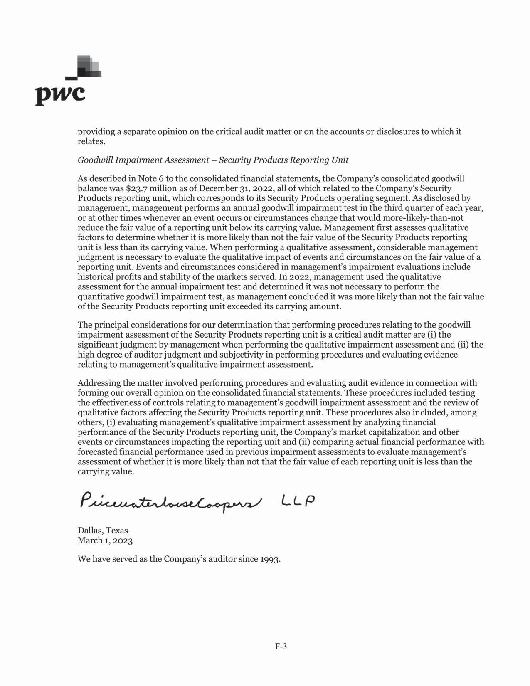

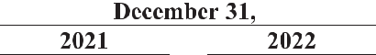
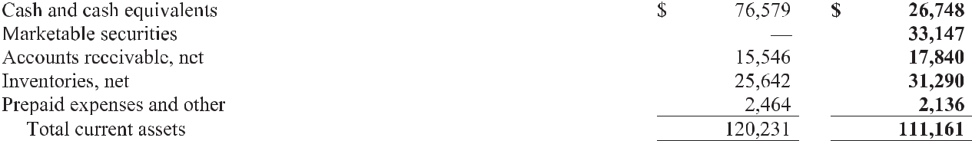
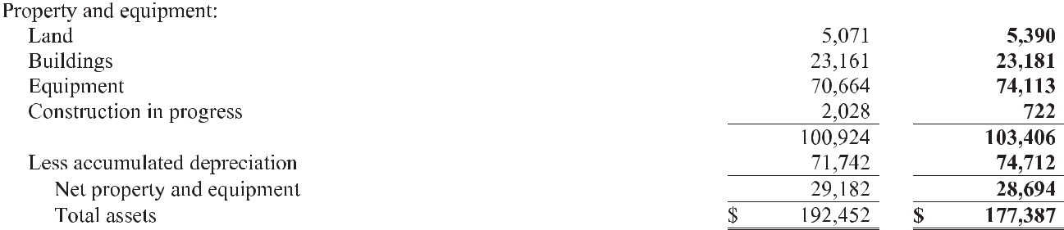
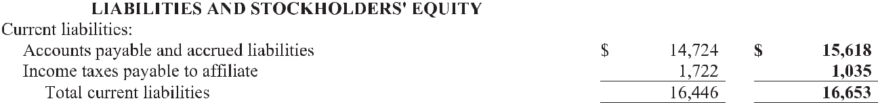
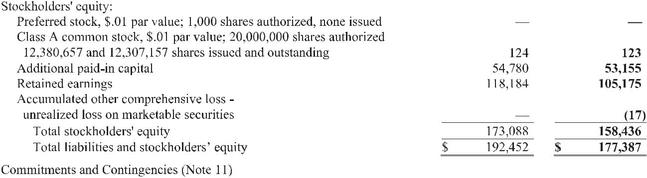

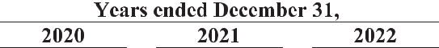
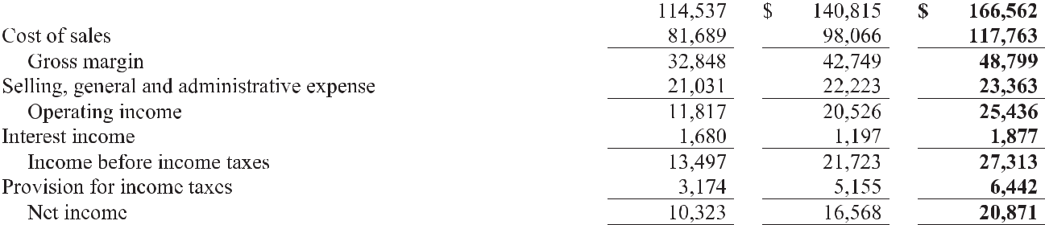

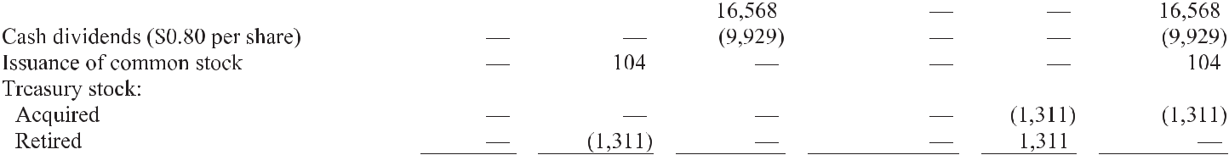
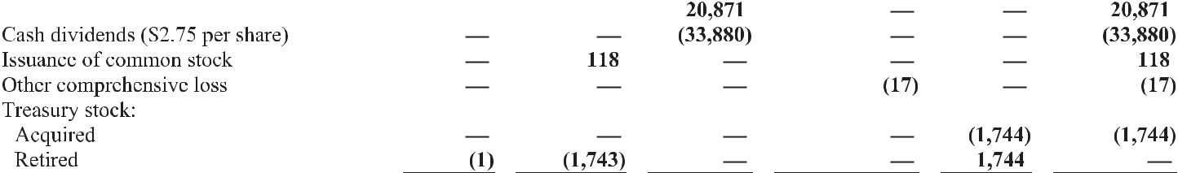

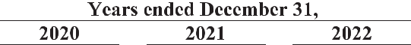
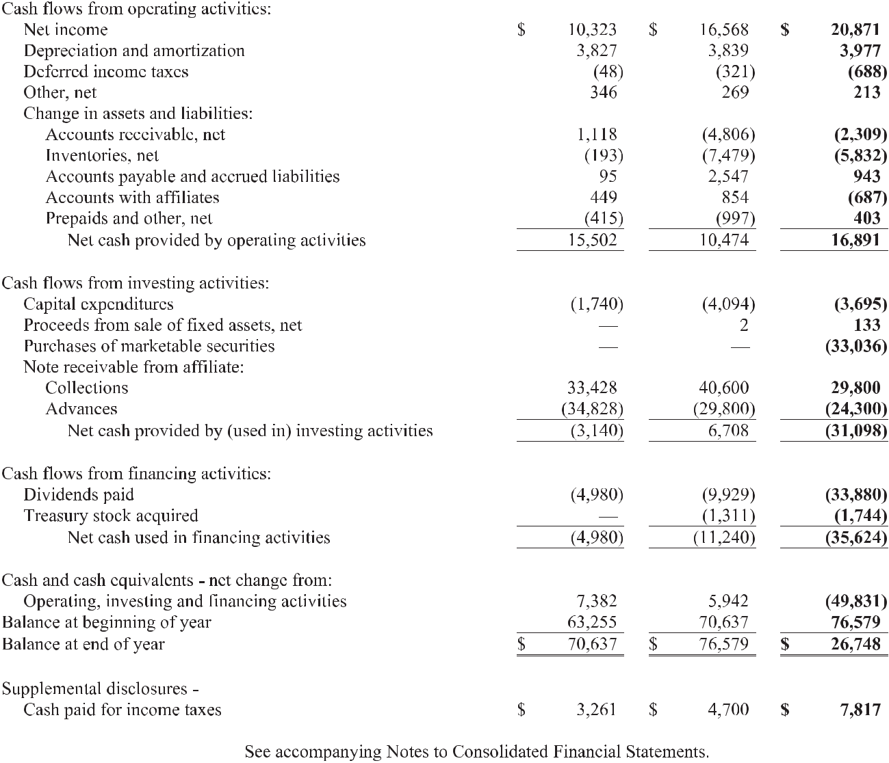

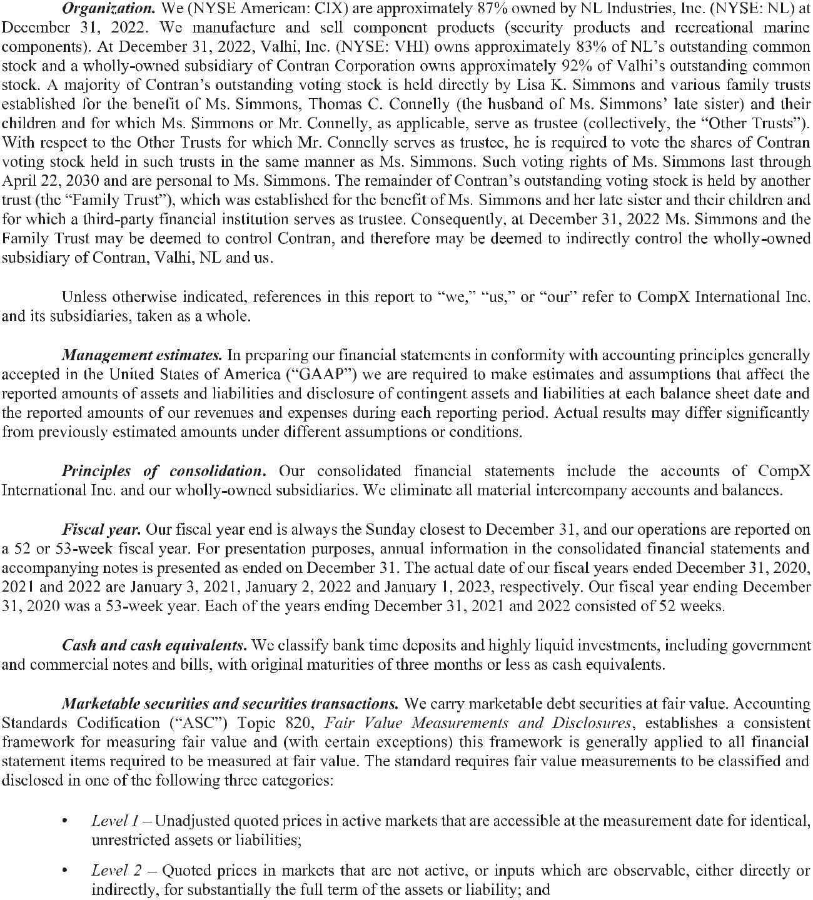

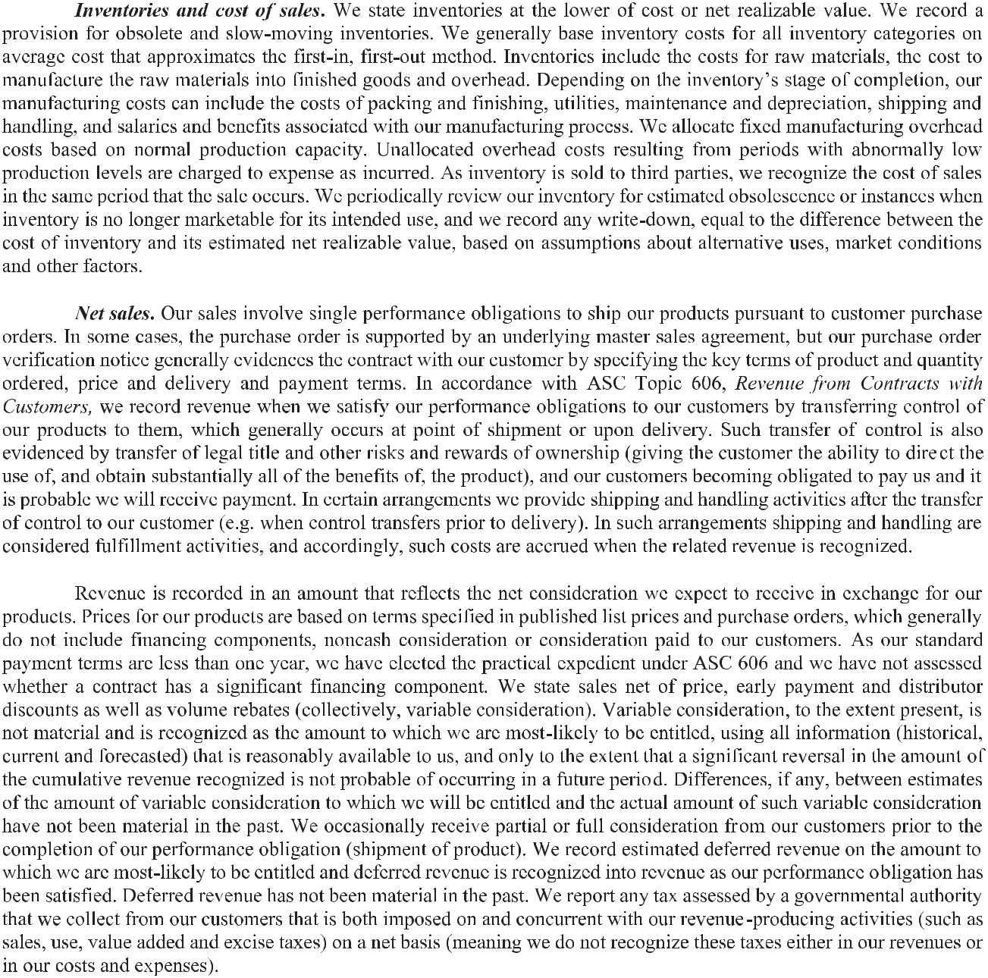

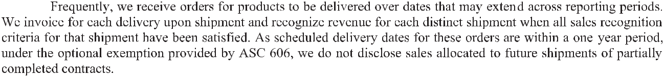
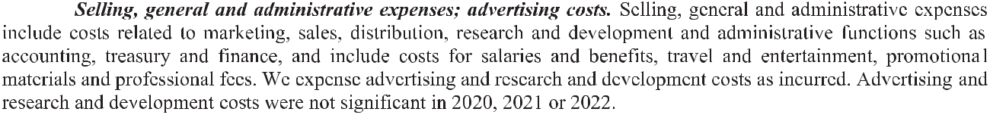
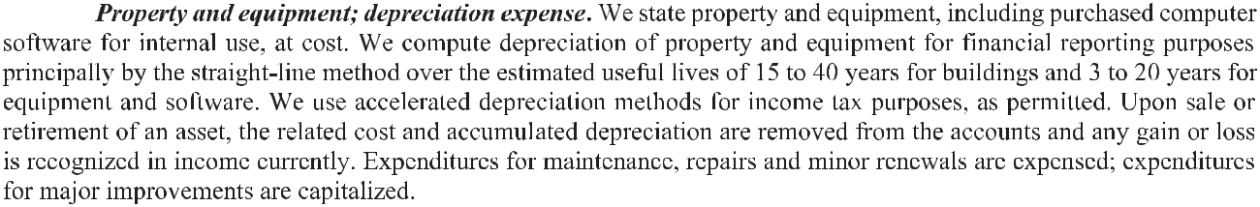
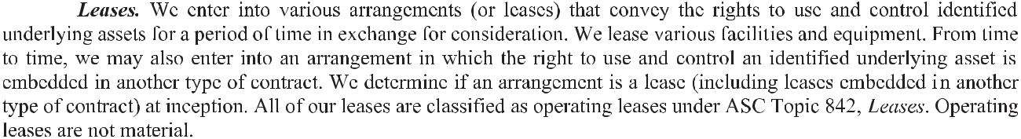

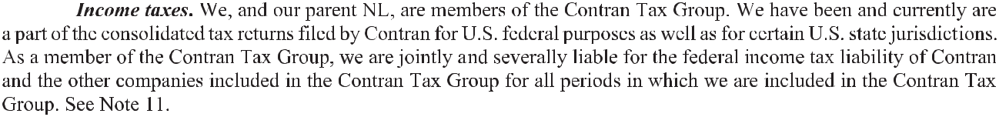

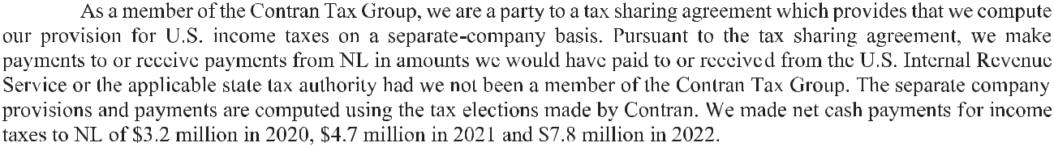
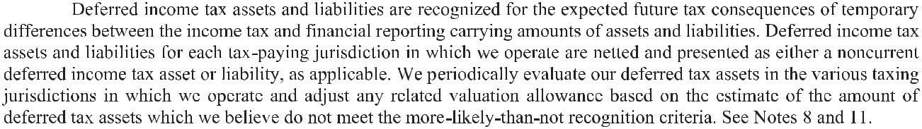
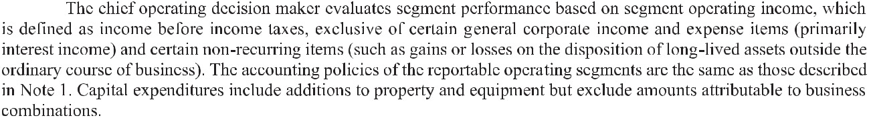
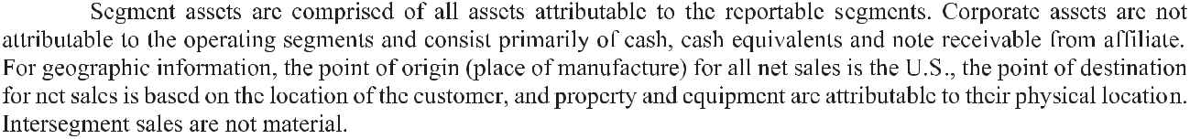

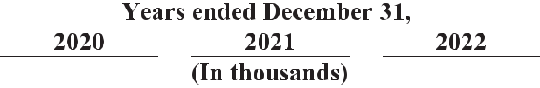
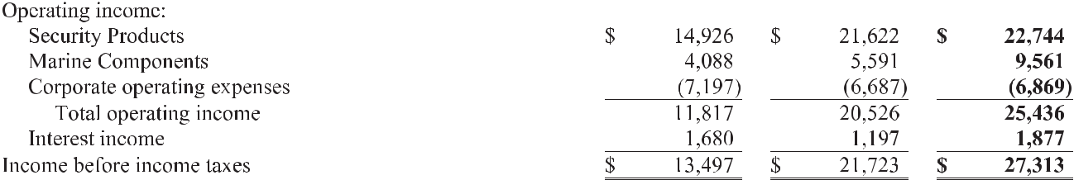
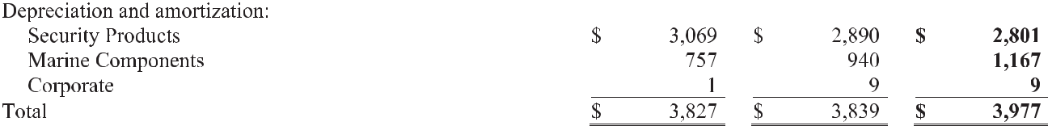
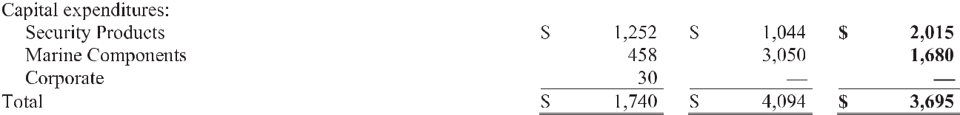
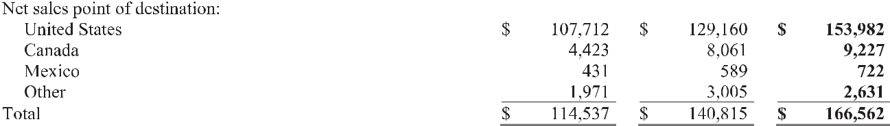
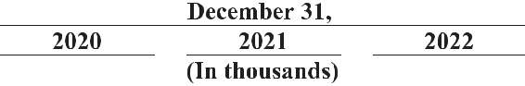


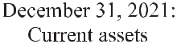
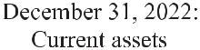
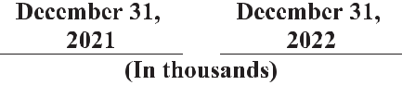
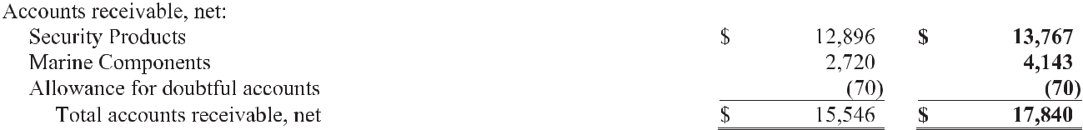
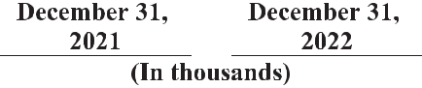
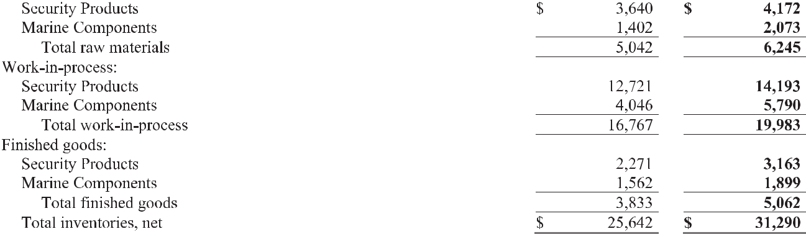

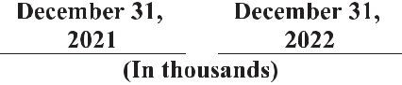
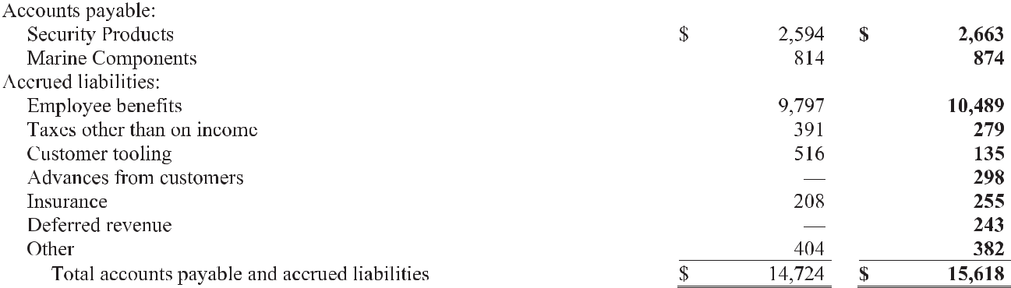
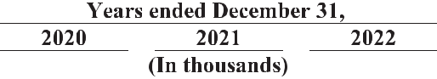
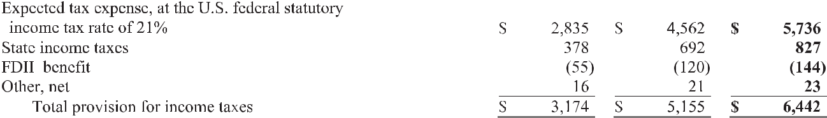

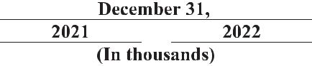
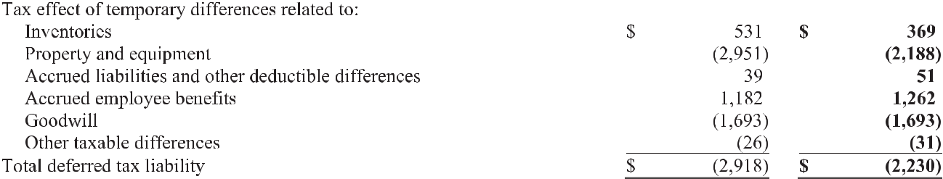
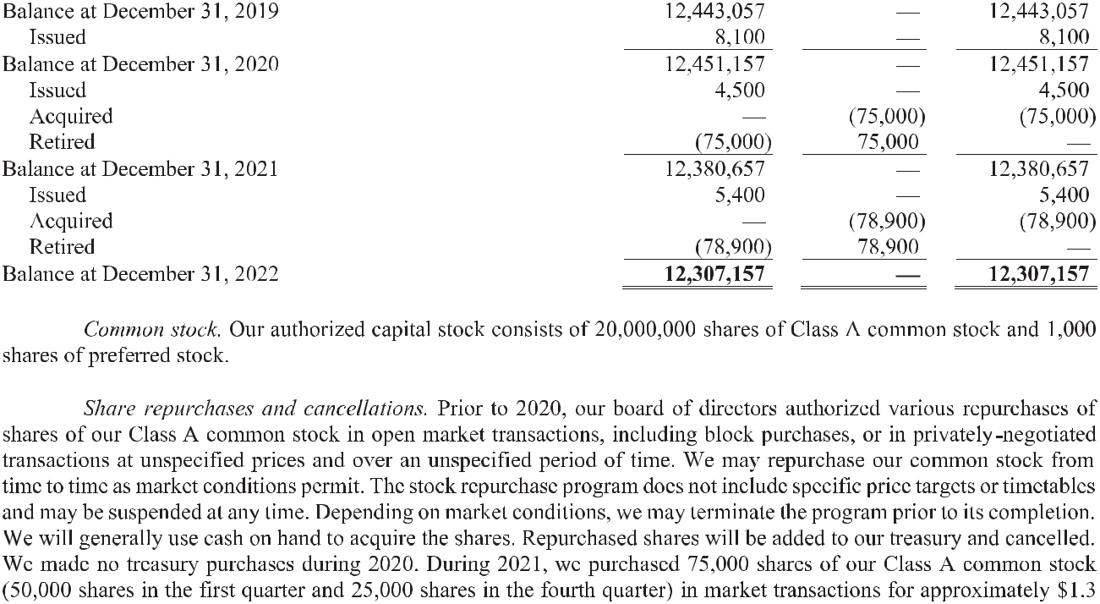

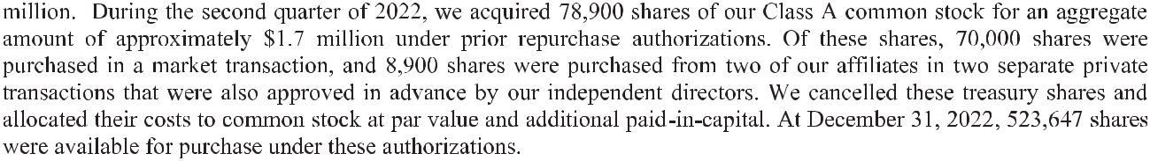
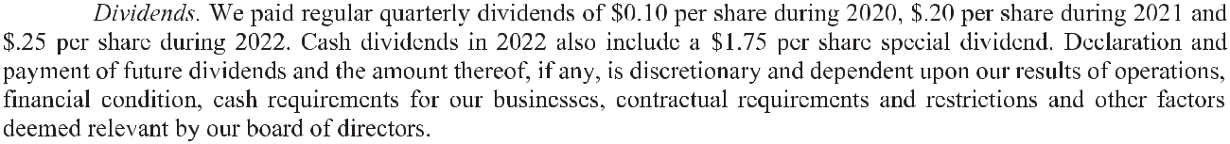
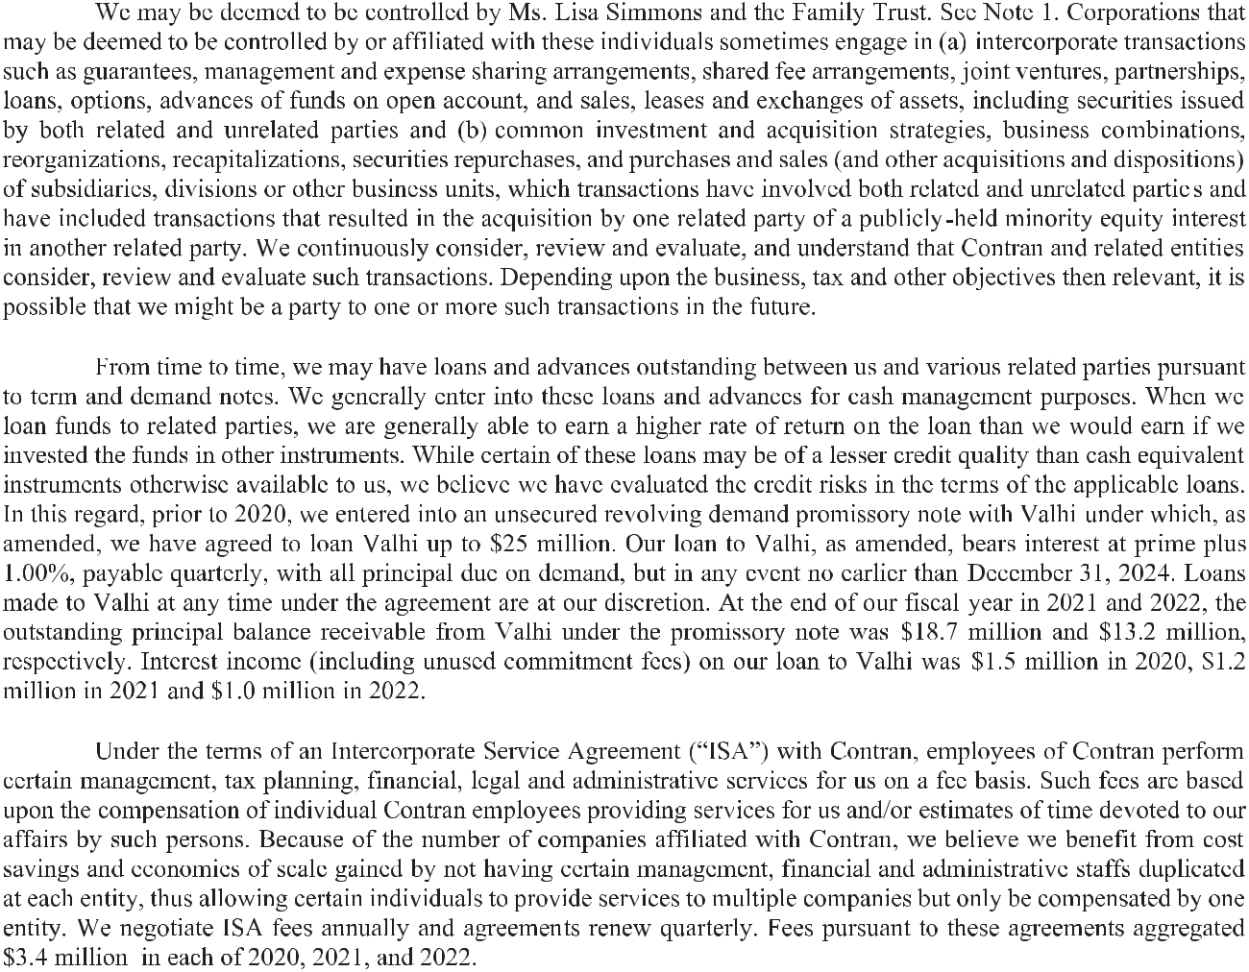

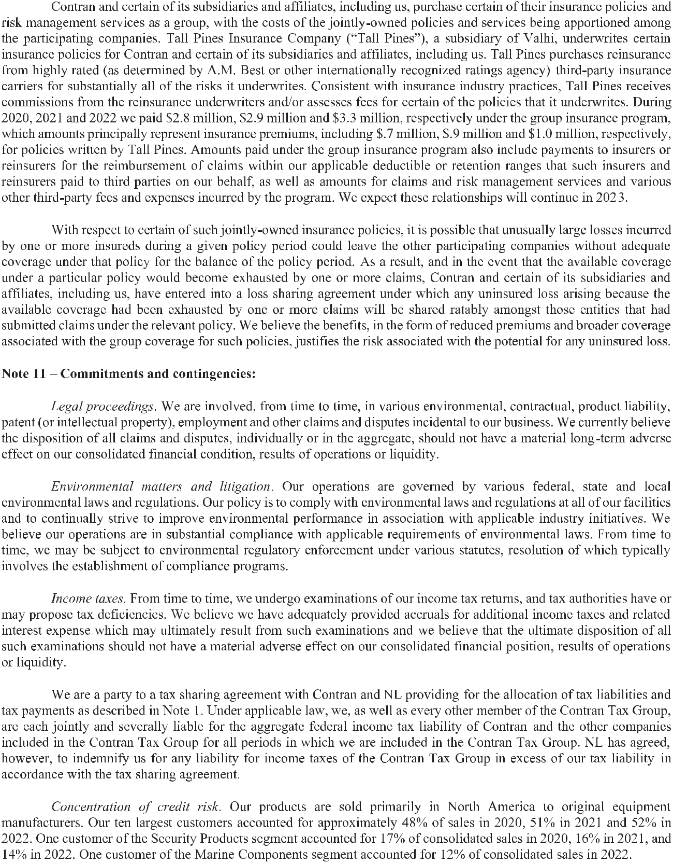

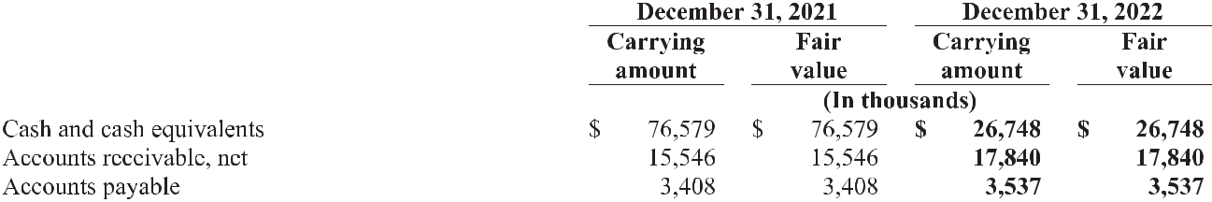

BOARD OF | EXECUTIVE
DIRECTORS | OFFICERS
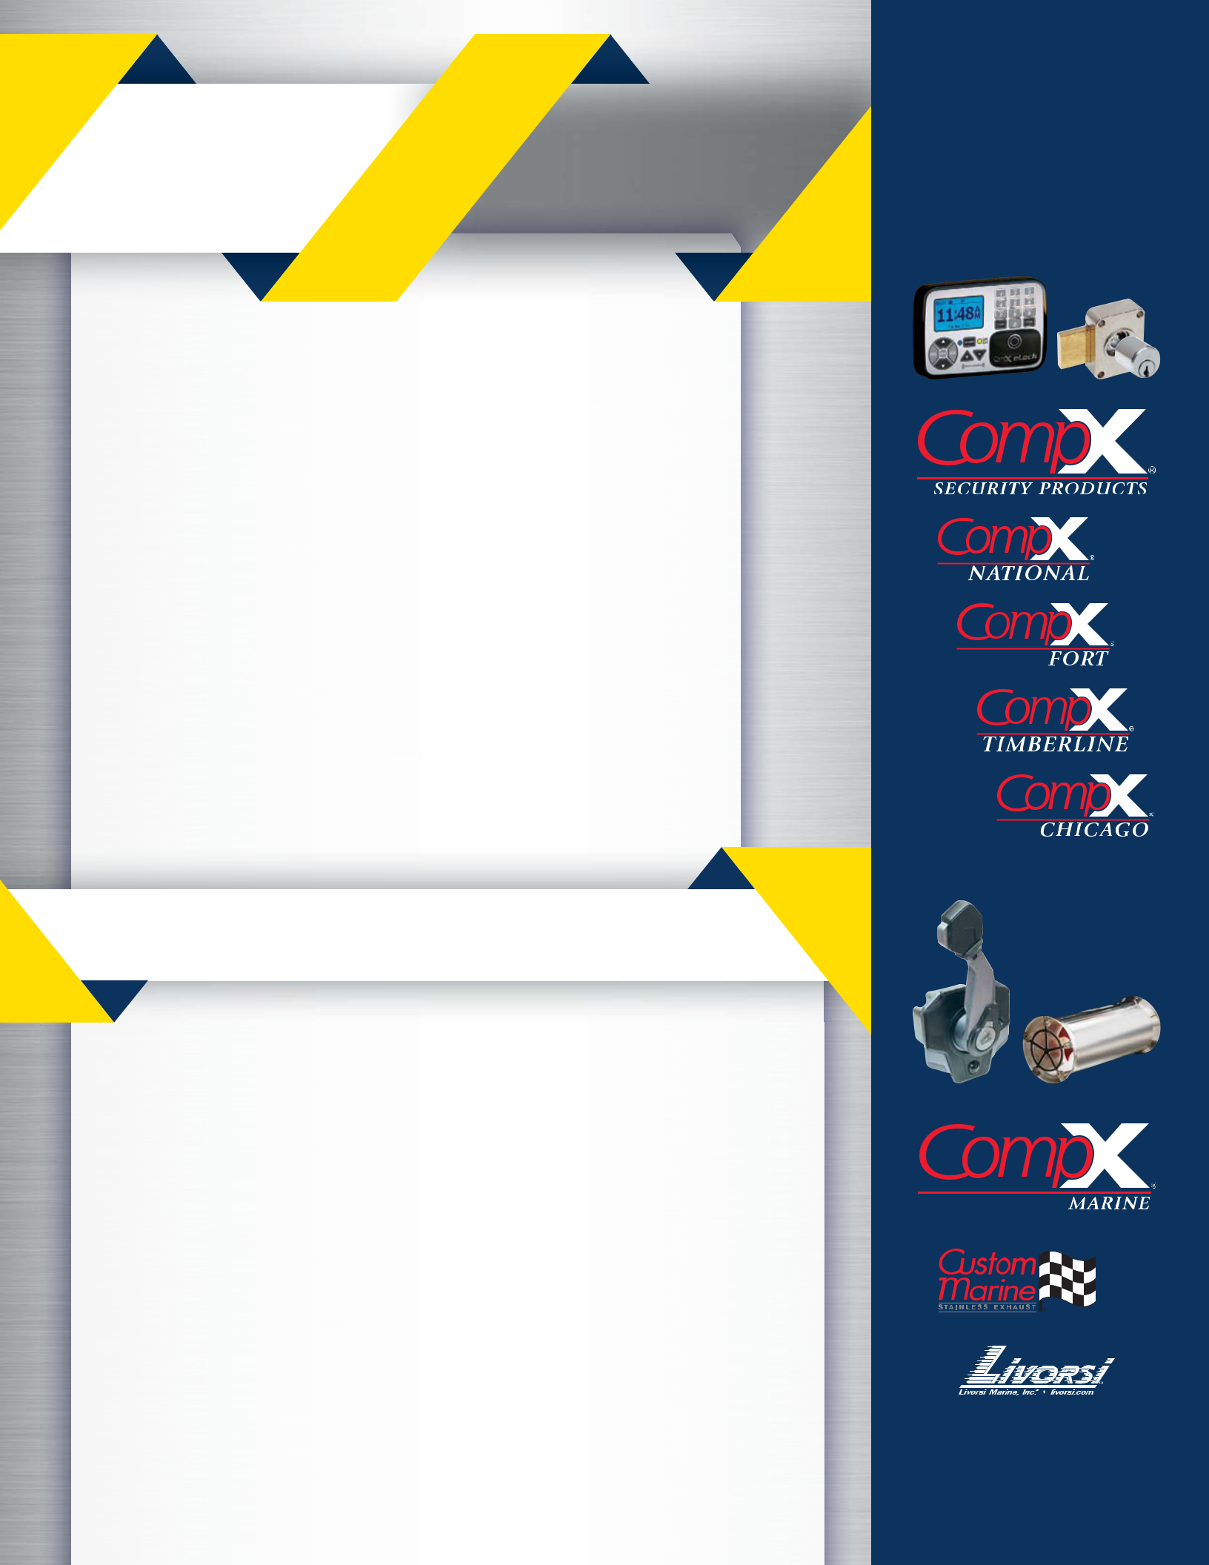

Loretta J. Feehan | Michael S. Simmons
Chair of the Board | Vice Chairman of the Board
(non executive) | Scott C. James
Financial Consultant | Scott C. James
Financial Consultant | President
Michael S. Simmons | and Chief Executive Officer
Vice Chairman of the Board | Andrew B. Nace
Thomas E. Barry | Executive Vice President
Emeritus Professor of Marketing | Amy A. Samford
Southern Methodist University | Amy A. Samford
Southern Methodist University | Executive Vice President
Terri L. Herrington | and Chief Financial Officer
Private Investor | Bryan A. Hanley
Scott C. James | Senior Vice President
President | and Treasurer
and Chief Executive Officer | Jane R. Grimm
Kevin B. Kramer | Vice President, General Counsel
Senior Vice President, | and Secretary
Chief Commerical | Bart W. Reichert
and Marketing Officer | Bart W. Reichert
and Marketing Officer | Vice President, Internal Audit
Allegheny Technologies, Inc. | Vice President, Internal Audit
Ann Manix | Amy E. Ruf
Ann Manix | Vice President and Controller
Director | Vice President and Controller
Blue Canyon Partners, Inc. | Darci B. Scott
Mary A. Tidlund | Vice President, Tax
Private Investor

STOCKHOLDER INFORMATION

Exchange Listing

CompX International Inc. Class A Common Stock is traded on the NYSE American under the symbol “CIX”

Annual Meeting

The annual meeting of stockholders will be held

Wednesday, May 24, 2023, at 10:00 a.m. at:

Corporate Headquarters CompX International Inc. The Conference Center at Three Lincoln Centre

5430 LBJ Freeway, Suite 350 Dallas, Texas 75240

All stockholders are welcome to attend.

Transfer Agent & Registrar Computershare Trust Company, N. A. P.O. Box 43006

Providence, RI 02940-3006 877.373.6374

Form 10-K Report

The Company's Annual Report on Form 10-K for the year ended December 31, 2022, as filed with the Securities and Exchange Commission, is included as part of this Annual Report.

Copies of the Annual Report are available free of charge at the Company's website at

compxinternational.com. Copies are also available without charge upon written request to:

Bryan A. Hanley

Investor Relations

Jane R. Grimm

Secretary

CompX International Inc.

Three Lincoln Centre

5430 LBJ Freeway, Suite 1700

Dallas, TX 75240

972.448.1400 | compxinternational.com

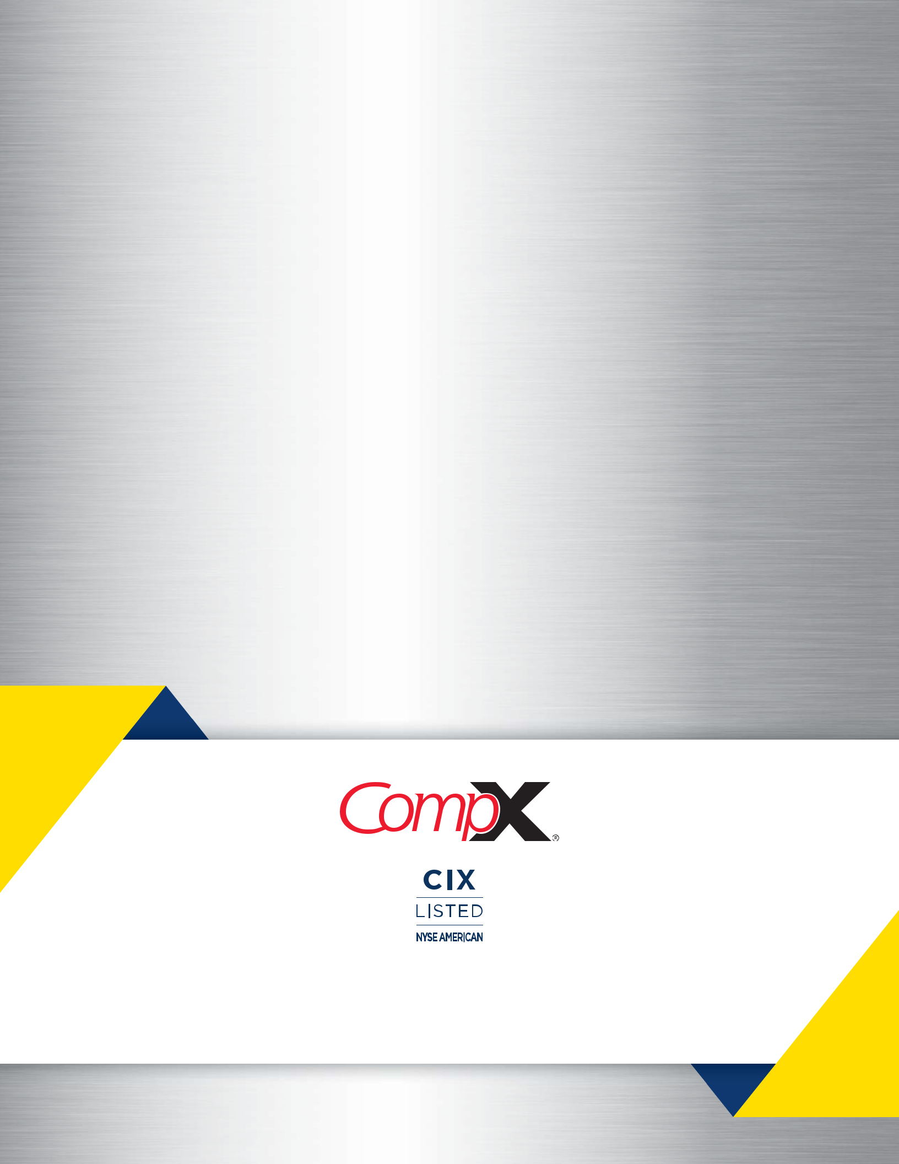

972.44 8.14 00 | C O M PXI NTE R NATI O NAL .C O M

Copyright 2023 © CompX International Inc. / Three Lincoln Centre / 5430 LBJ Freeway / Suite 1700 / Dallas, TX 75240

Any companies and/or products referred to herein are marks or registered trademarks of their respective companies, owners and/or mark holders.

