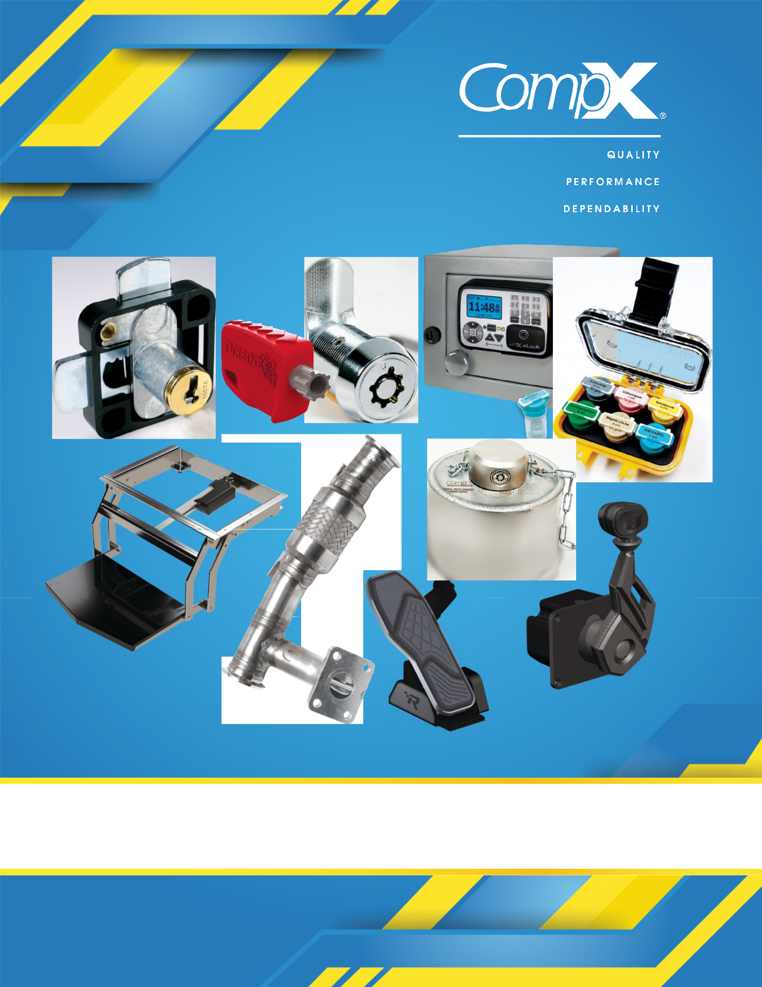

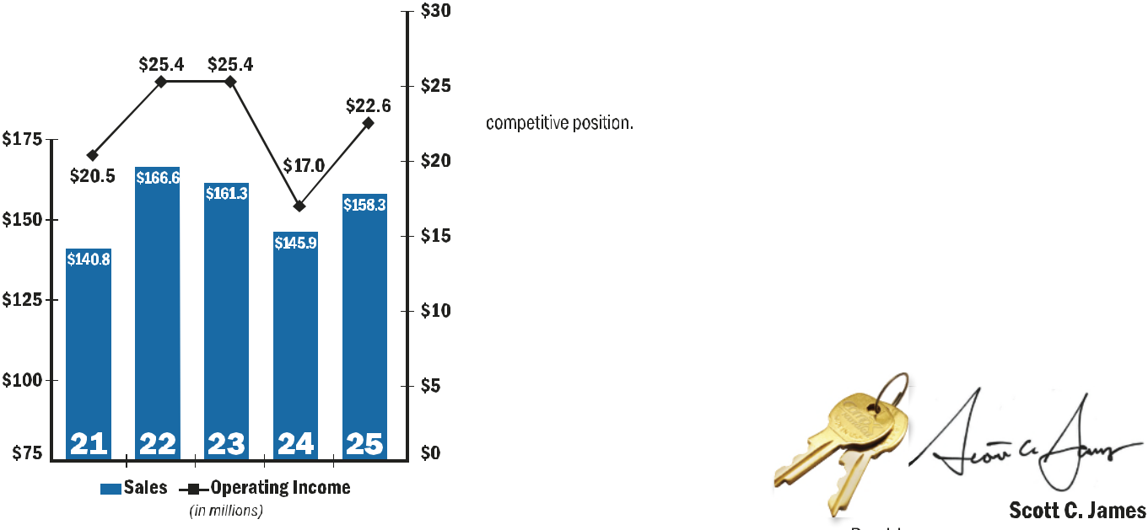





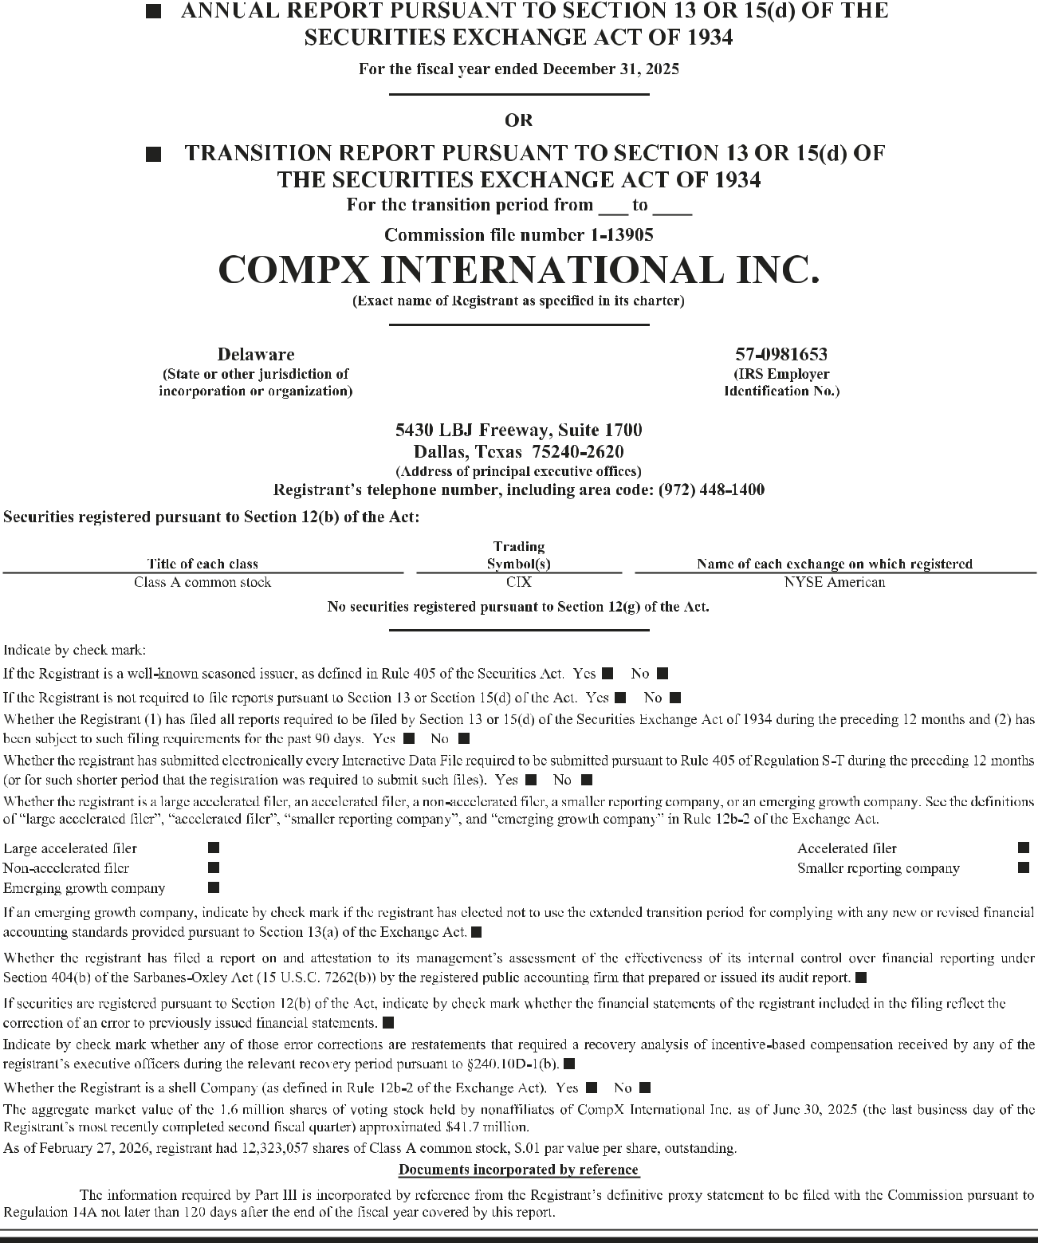

PART I

ITEM 1. BUSINESS

General

CompX International Inc. (NYSE American: CIX), incorporated in Delaware in 1993, is a leading manufacturer of security products used in the postal, recreational transportation, office and institutional furniture, cabinetry, tool storage, healthcare applications and a variety of other industries. We are also a leading manufacturer of wake enhancement systems, stainless steel exhaust systems, gauges, throttle controls and trim tabs and related hardware and accessories for the recreational marine and various other industries. Our products are principally designed for use in medium to high-end product applications where design, quality and durability are valued by our customers.

At December 31, 2025, NL Industries, Inc. (NYSE: NL) owns approximately 87% of our outstanding common stock, Valhi, Inc. (NYSE: VHI) owns approximately 83% of NL’s outstanding common stock and a subsidiary of Contran Corporation owns approximately 91% of Valhi’s outstanding common stock. As discussed in Note 1 to our Consolidated Financial Statements, a majority of Contran’s outstanding voting stock is held directly by Lisa K. Simmons, and by family stockholders (Thomas C. Connelly (the husband of Ms. Simmons’ late sister), a family-owned entity and various family trusts established for the benefit of Ms. Simmons, Mr. Connelly and their children) who are required to vote their shares of Contran voting stock in the same manner as Ms. Simmons. Such voting rights are personal to Ms. Simmons and last through April 22, 2030. The remainder of Contran’s outstanding voting stock is held by another trust (the “Family Trust”), which was established for the benefit of Ms. Simmons and her late sister and their children and for which a third-party financial institution serves as trustee. Consequently, at December 31, 2025, Ms. Simmons and the Family Trust may be deemed to control Contran, and therefore may be deemed to indirectly control the wholly-owned subsidiary of Contran, Valhi, NL and us.

Our corporate offices are located at Three Lincoln Centre, 5430 LBJ Freeway, Suite 1700, Dallas, Texas 75240.
Our telephone number is (972) 448-1400. We maintain a website at www.compxinternational.com.

Unless otherwise indicated, references in this report to “we,” “us,” or “our” refer to CompX International Inc.
and its subsidiaries taken as a whole.

Forward-Looking Statements

This Annual Report on Form 10-K contains forward-looking statements within the meaning of the Private Securities Litigation Reform Act of 1995, as amended. Statements in this Annual Report that are not historical facts are forward-looking in nature and represent management’s beliefs and assumptions based on currently available information. In some cases, you can identify forward-looking statements by the use of words such as “believes,” “intends,” “may,” “should,” “could,” “anticipates,” “expects” or comparable terminology, or by discussions of strategies or trends. Although we believe the expectations reflected in such forward-looking statements are reasonable, we do not know if these expectations will be correct. Such statements by their nature involve substantial risks and uncertainties that could significantly impact expected results. Actual future results could differ materially from those predicted. The factors that could cause actual future results to differ materially from those described herein are the risks and uncertainties discussed in this Annual Report and those described from time to time in our other filings with the U.S. Securities and Exchange Commission (the “SEC”) and include, but are not limited to, the following:

•

•

•

•

•

Future supply and demand for our products;

Changes in our raw material and other operating costs (such as zinc, brass, aluminum, steel and energy costs) or the implementation of tariffs on imported raw materials and our ability to pass those costs on to our customers or offset them with reductions in other operating costs;

Price and product competition from low-cost manufacturing sources (such as China);

The impact of pricing and production decisions;

Customer and competitor strategies including substitute products;

- 2 -





